VPC TASK – 2

1.Create one VPC, with 1 public subnet and 1 private subnet.

Create one VPC

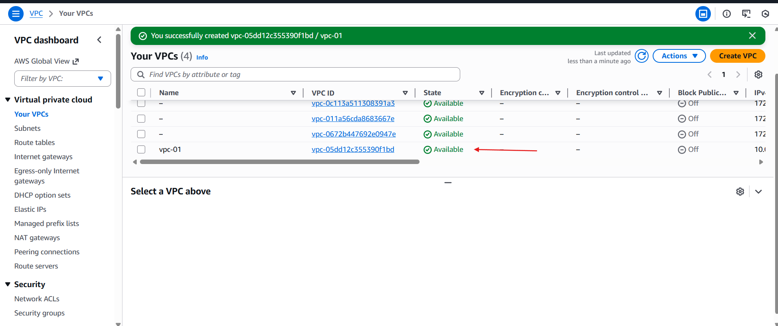

* Create 2 subnets one private and one pub

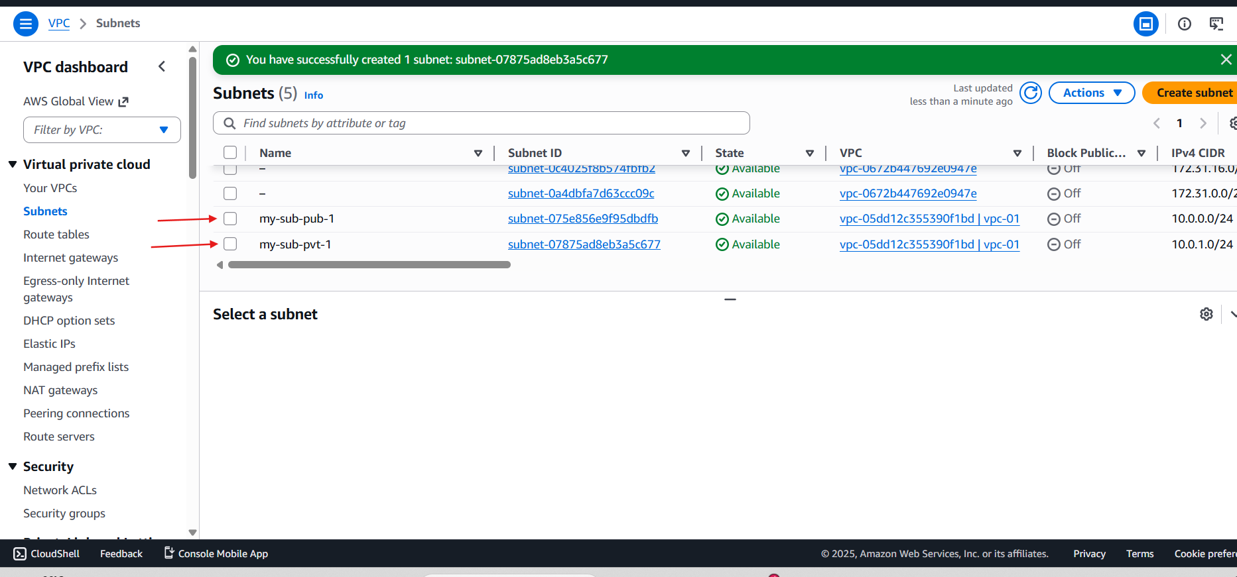

* Create internet gate and attached to VPC

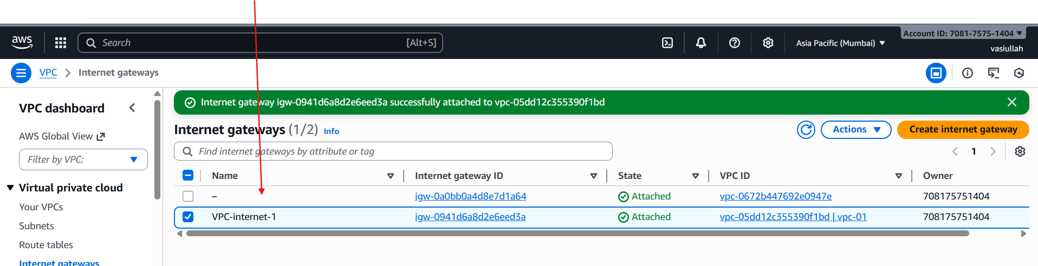

* Created the rout table
* One pub and one private

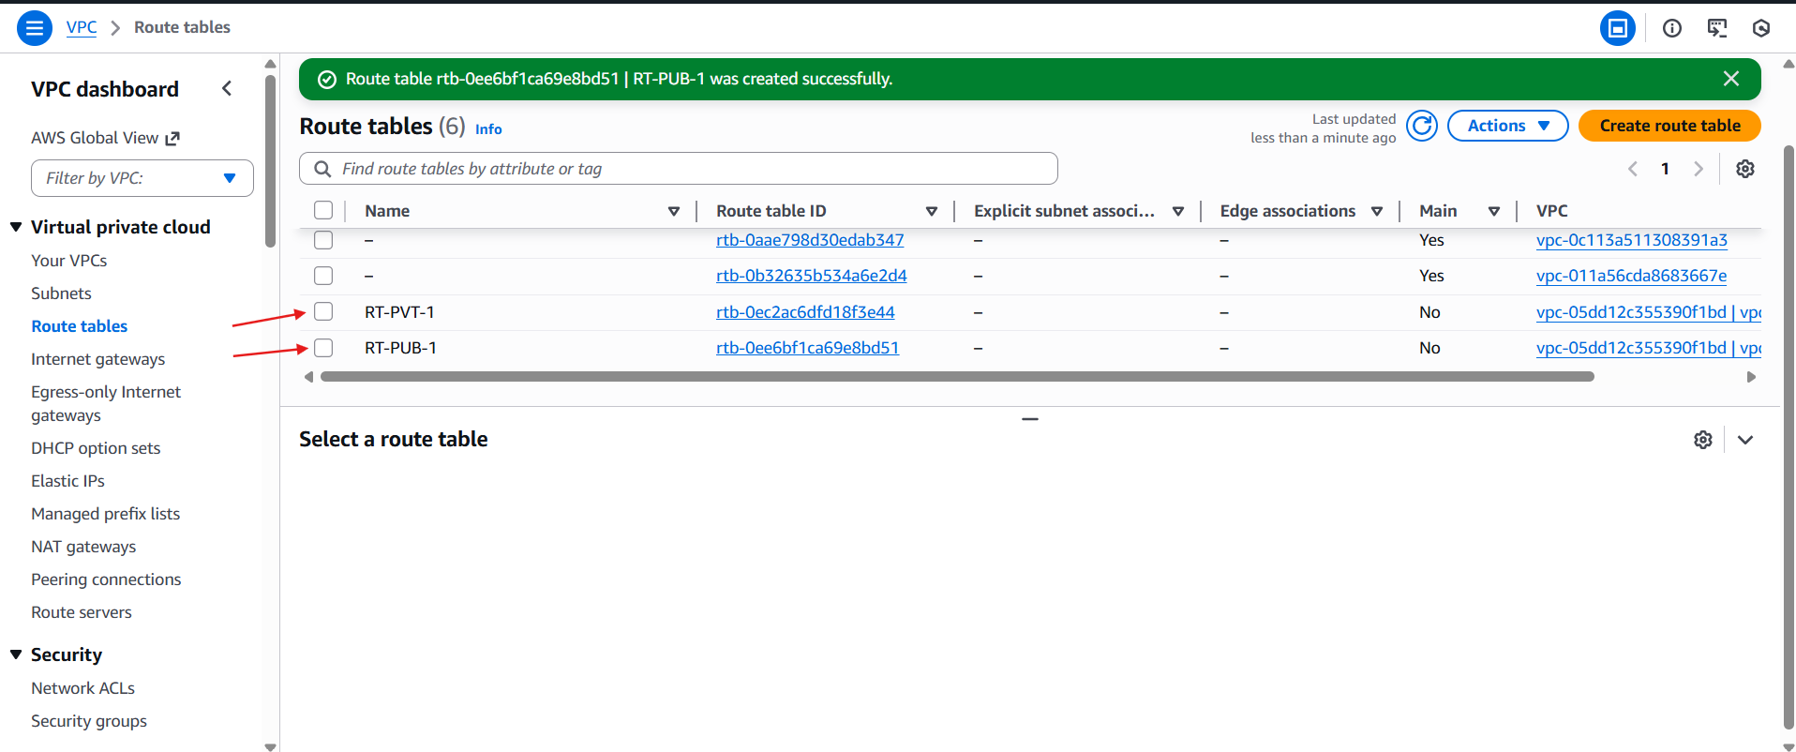

* Go to the edit routs
* For attach the internet gate way

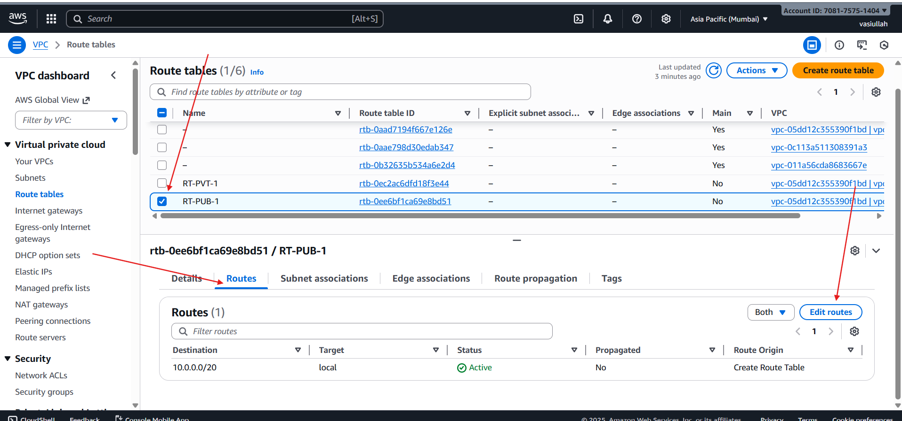

* Successfully internet gateway is attached

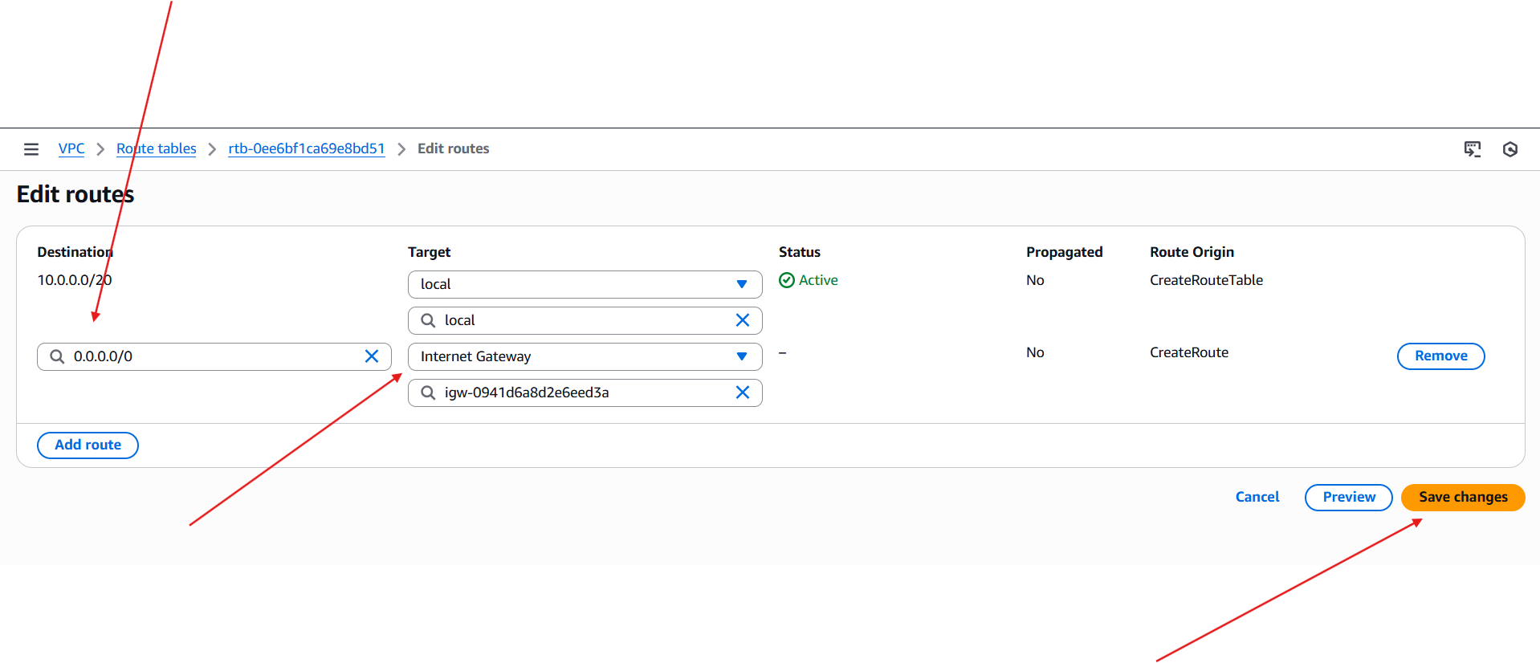

* Edited with subnet associate

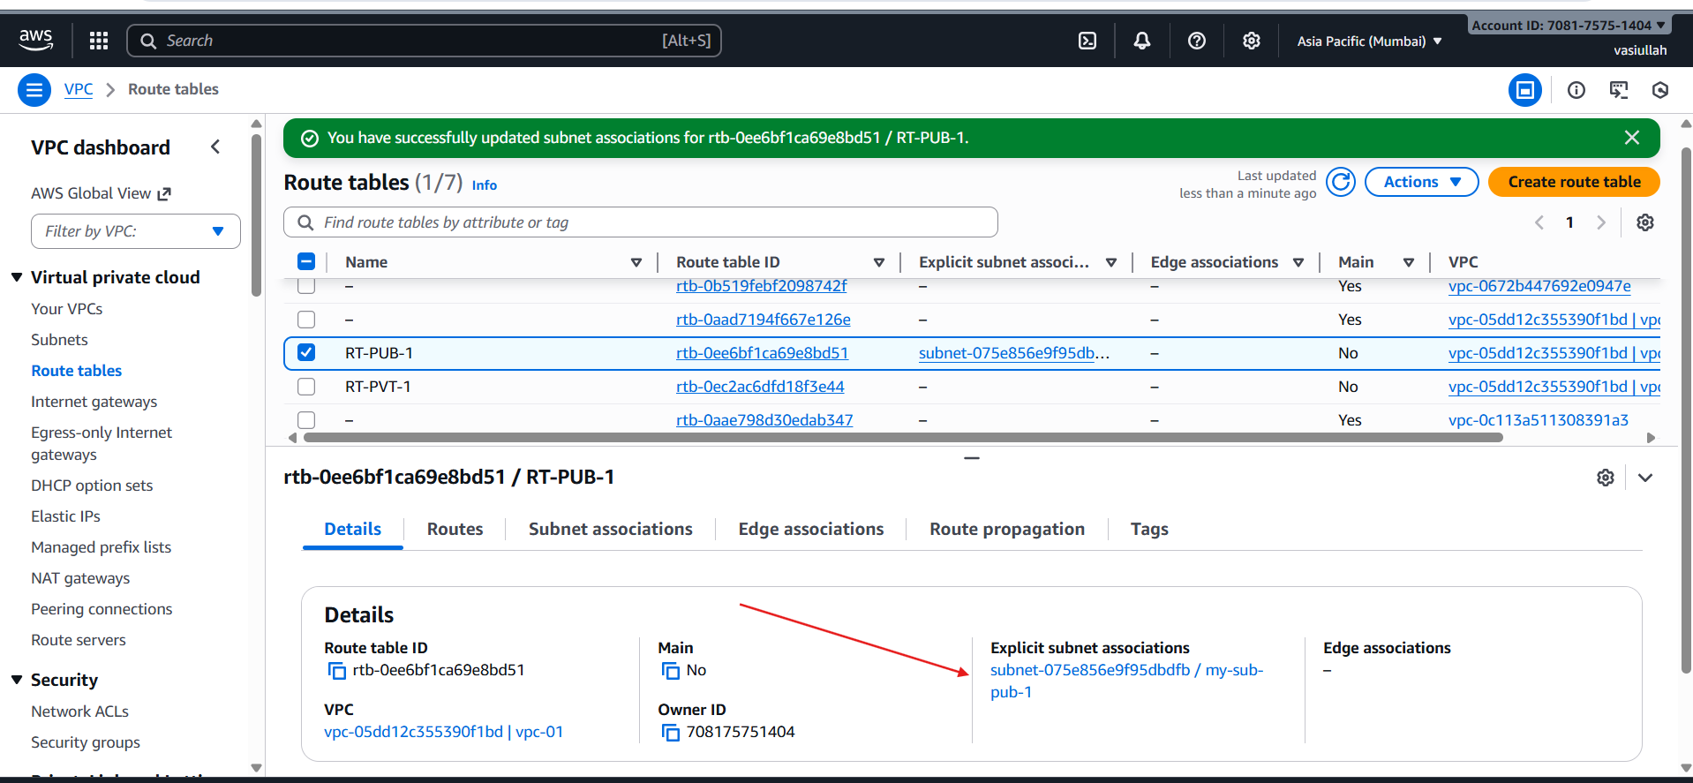

* Create one Nat gateway

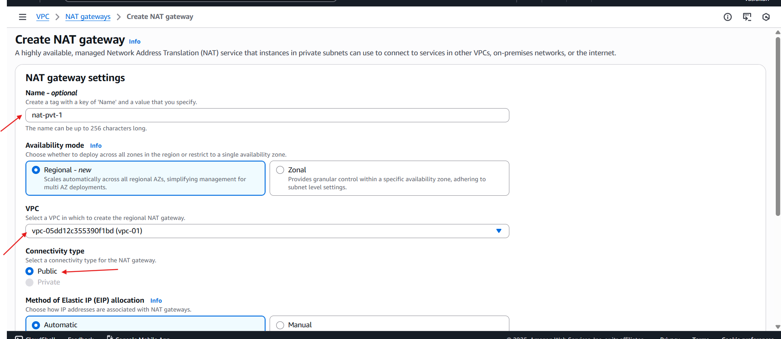

* Rout table addached to the inter for public I attachect internet gateway
* For private attached NAT gateway

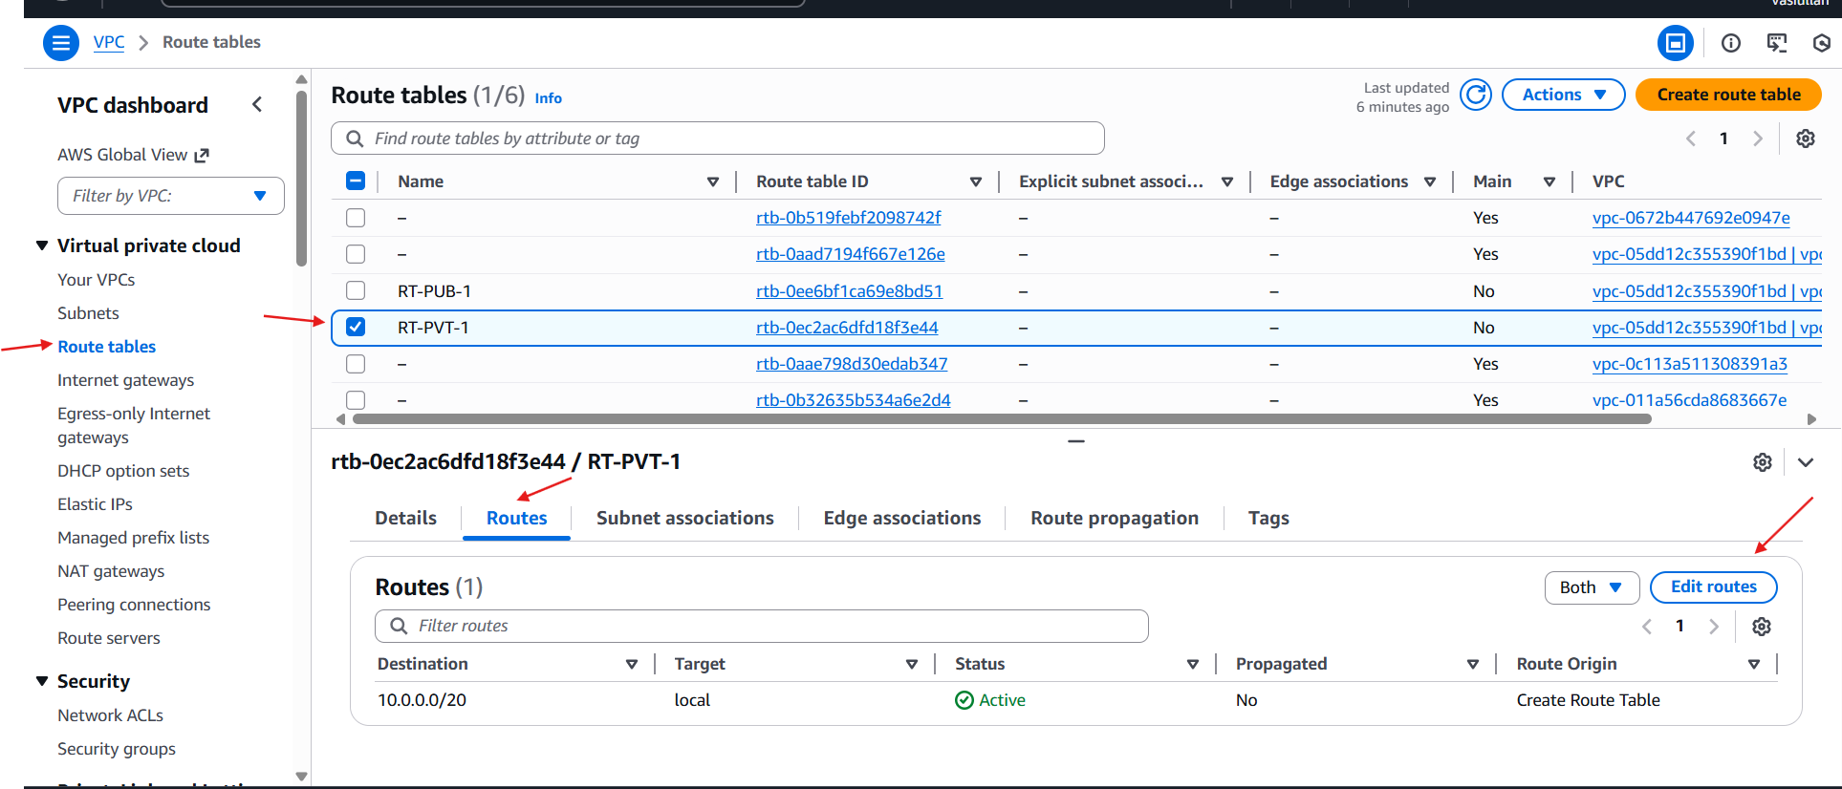

* For public I attached nat gate way

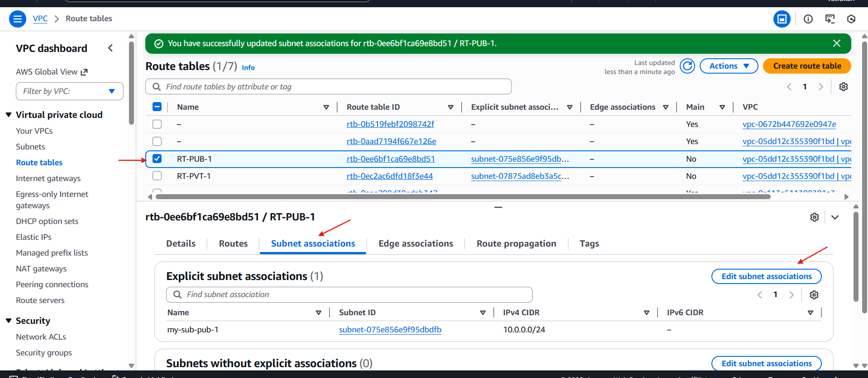

* Selected my public subnet and attached to Rout Table public
* For private I attached private rout

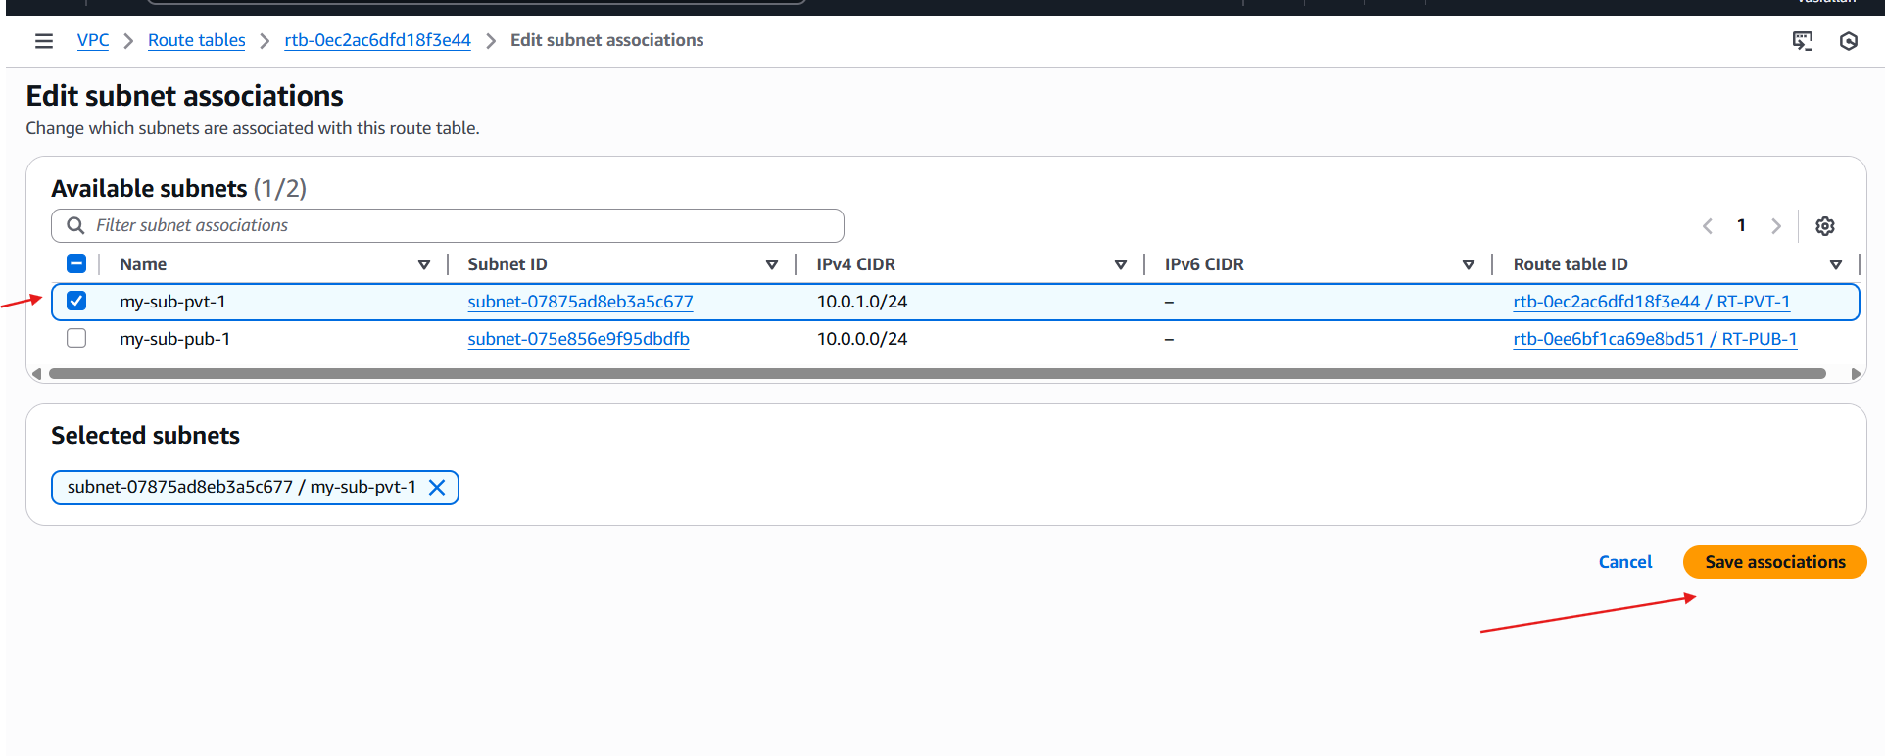

* Vpc resource Map

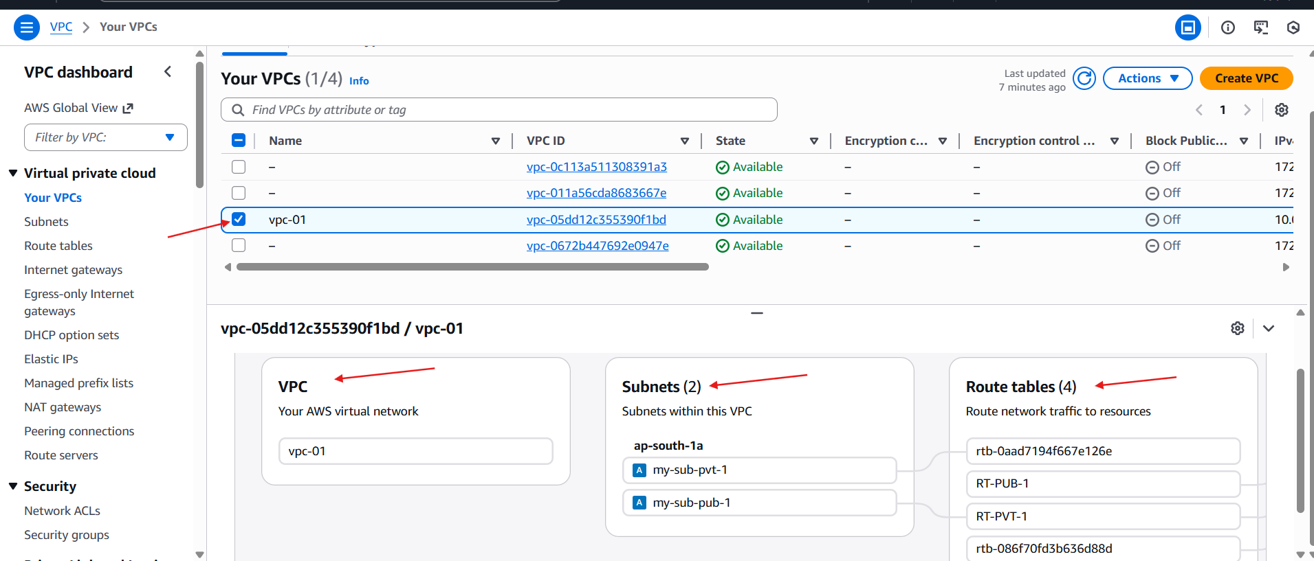

2. Enable VPC peering for cross-region.

* Region is set for 🡪Europe(lreland)
* Launch one ec2

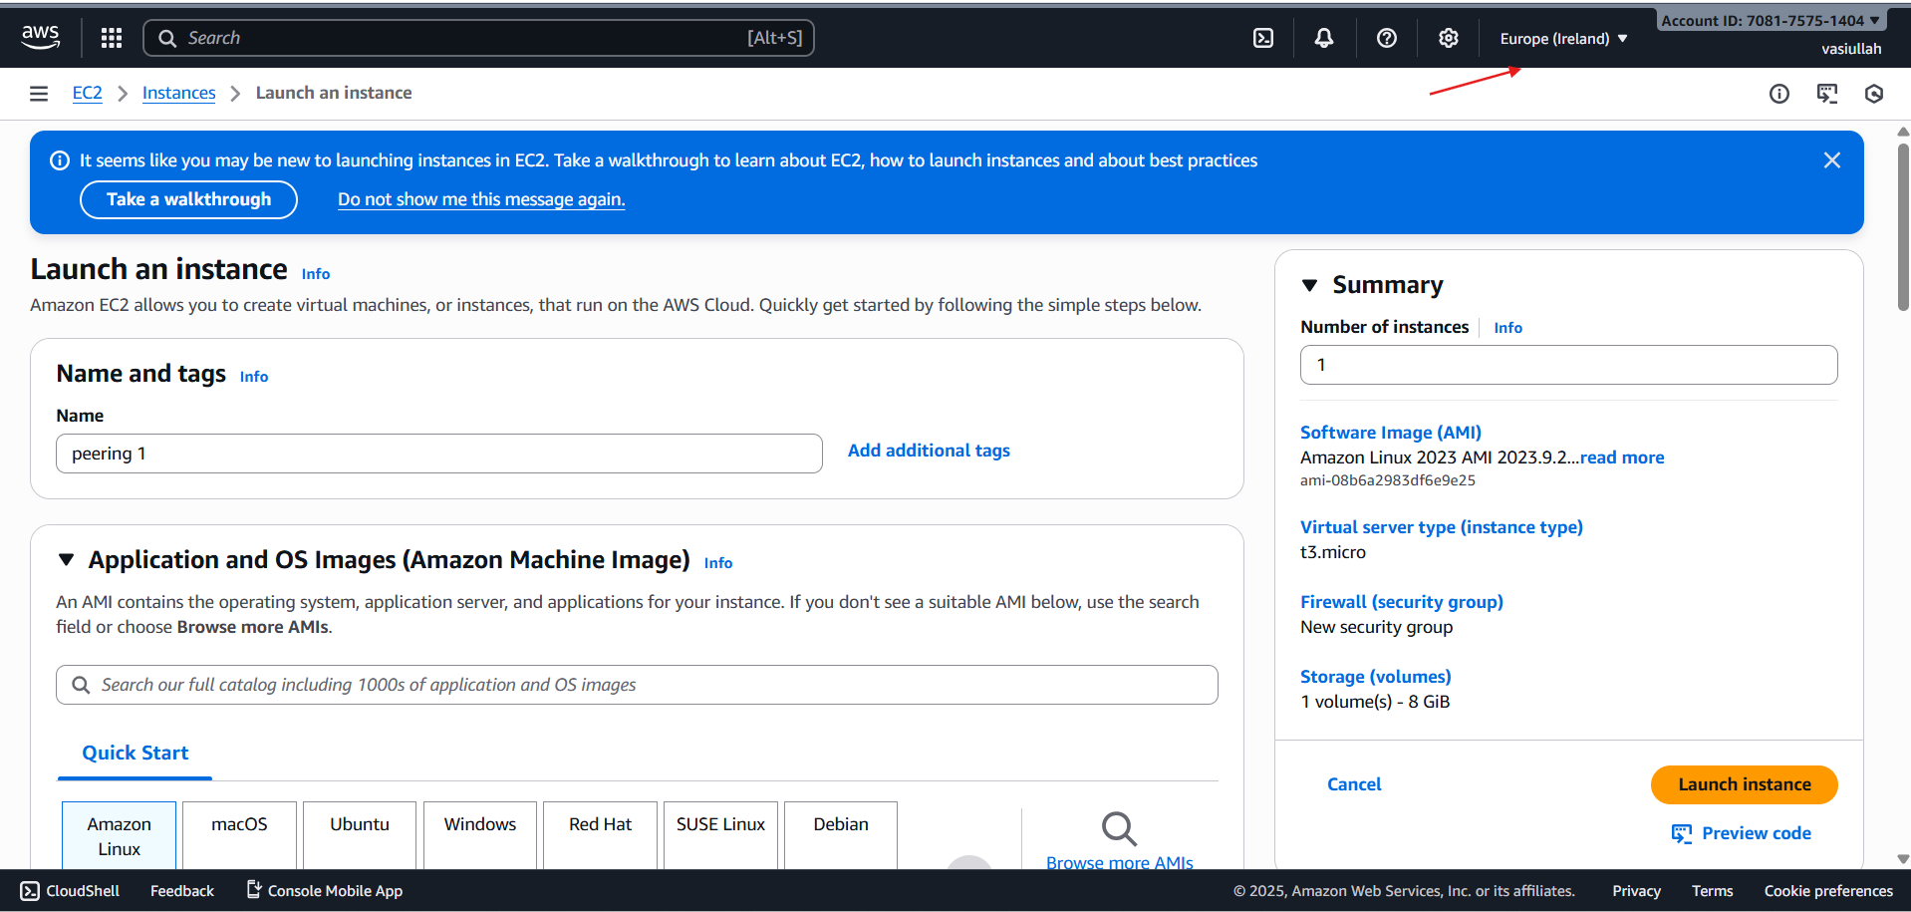

* Give required networs and security
* And launch the instance

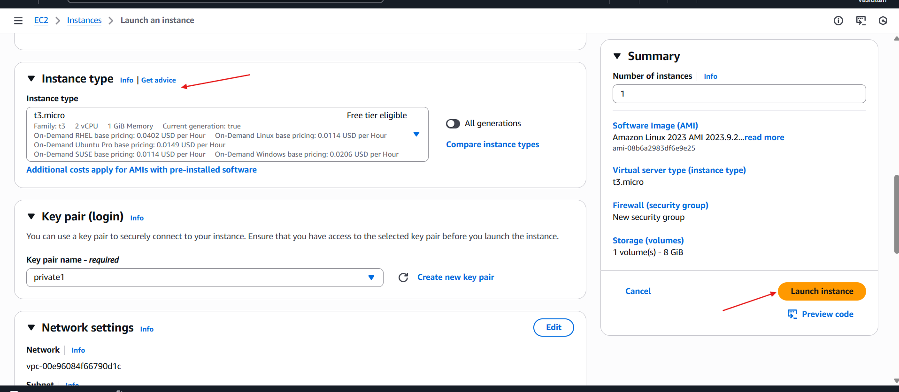

* **Change the region**
* **Ohio regio**

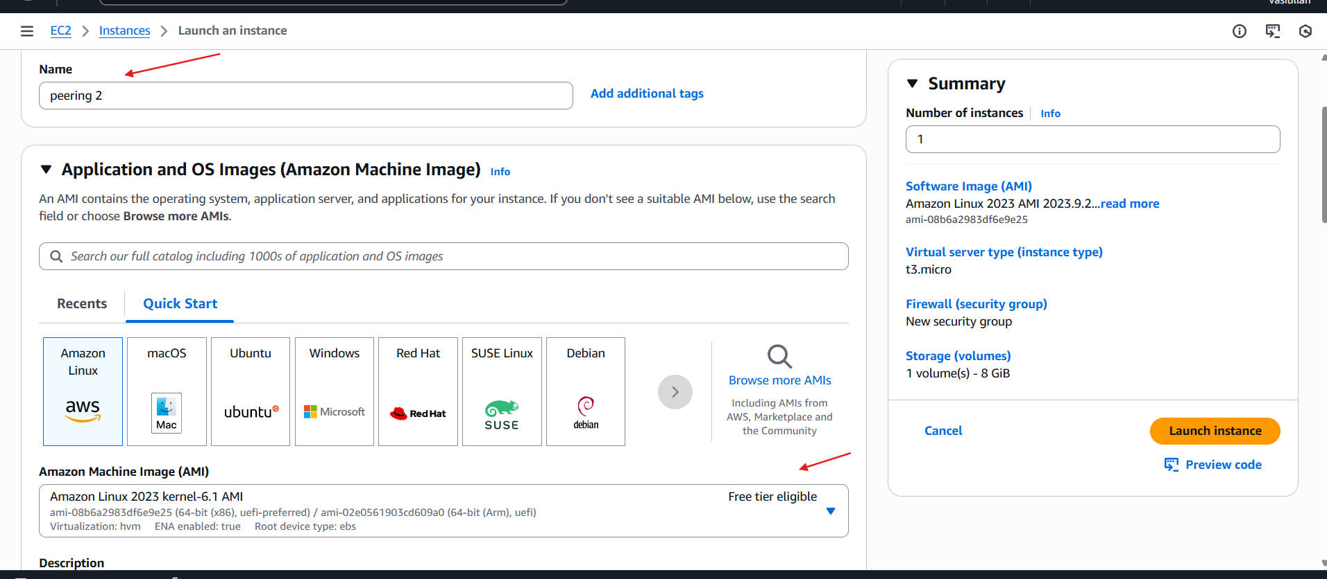

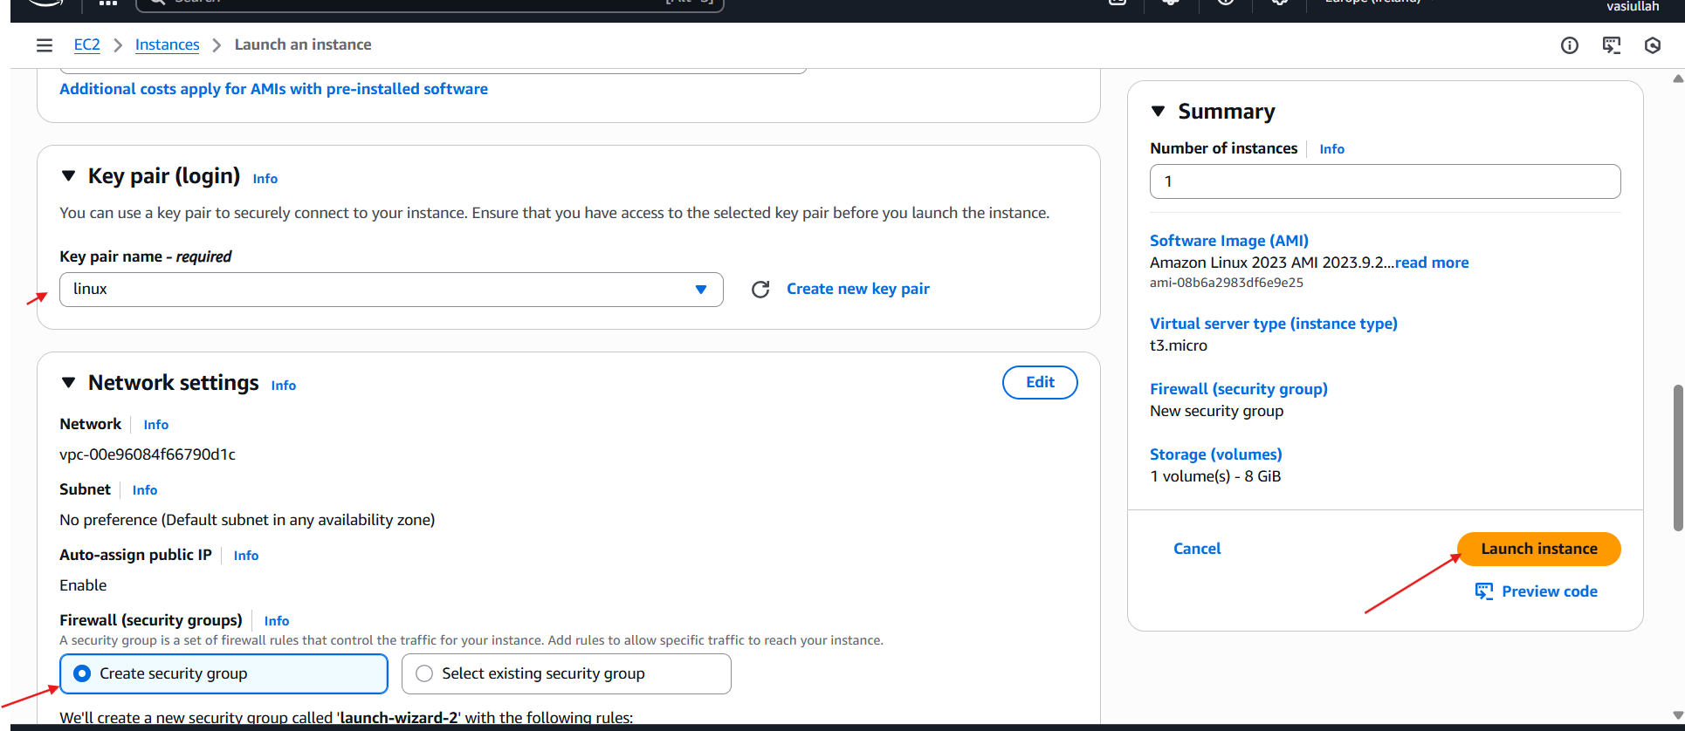

* **Ec2 is successfully launched**
* 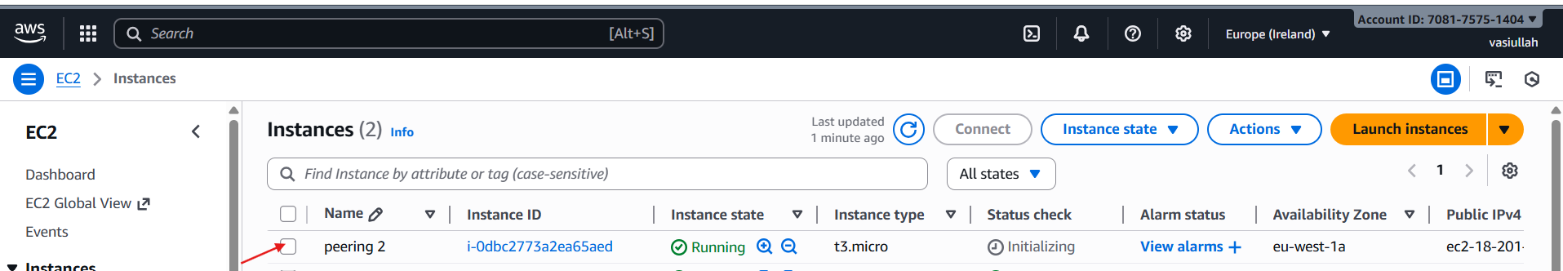
* **Create one VPC**

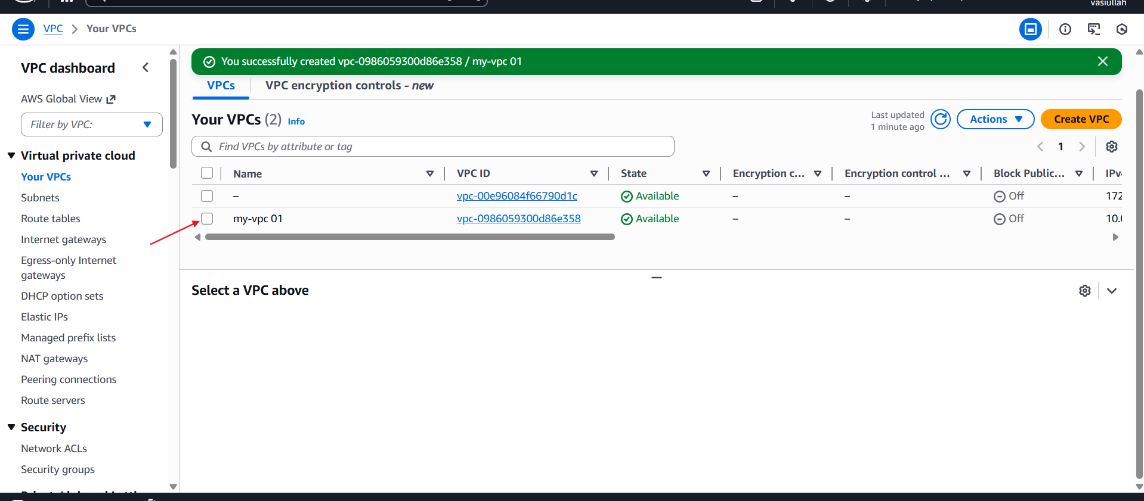

* **Go to the peering connection**

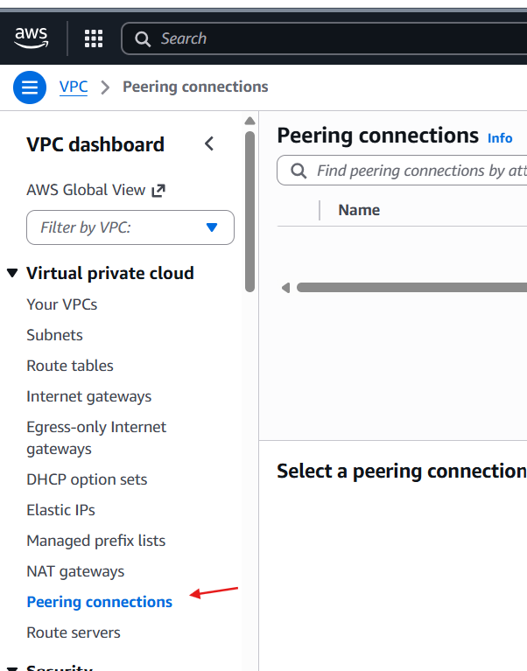

* **Create the peering connection**
* **Create peering connection** 🡪**select local VPC peering** 🡪**vpc id : kept default**

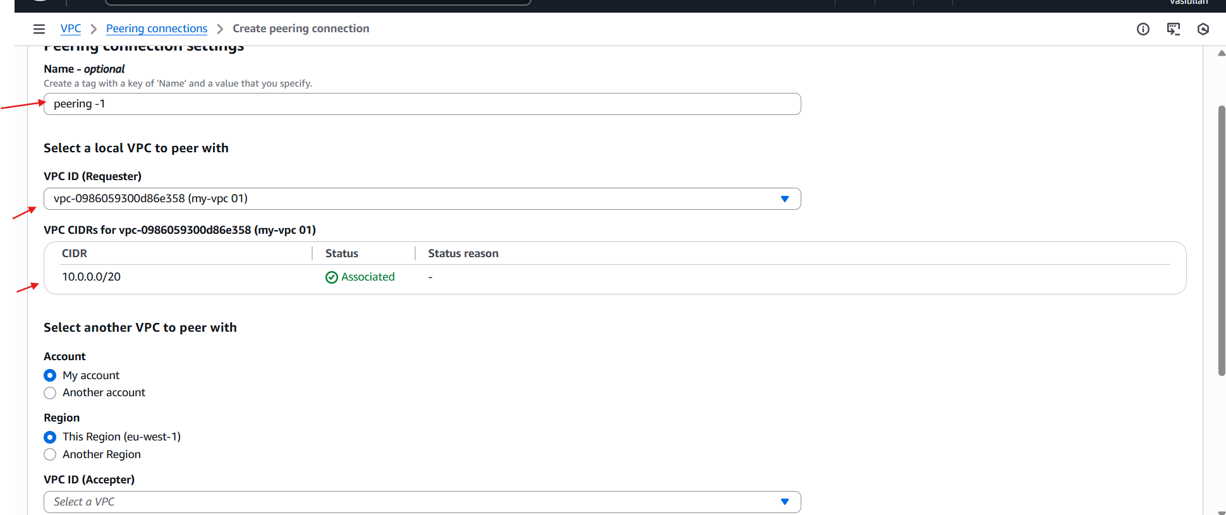

* **Go to the another region** 🡪 **VPC**🡪**Your vpc**🡪**already default VPC**

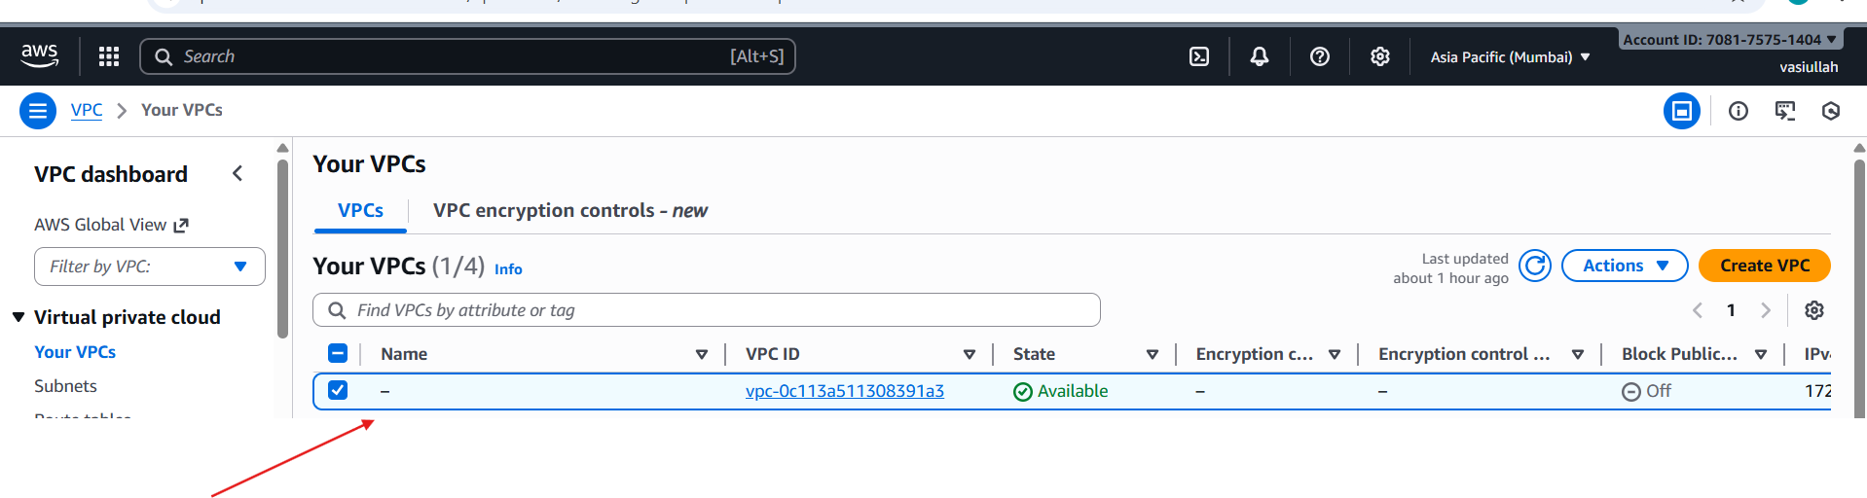

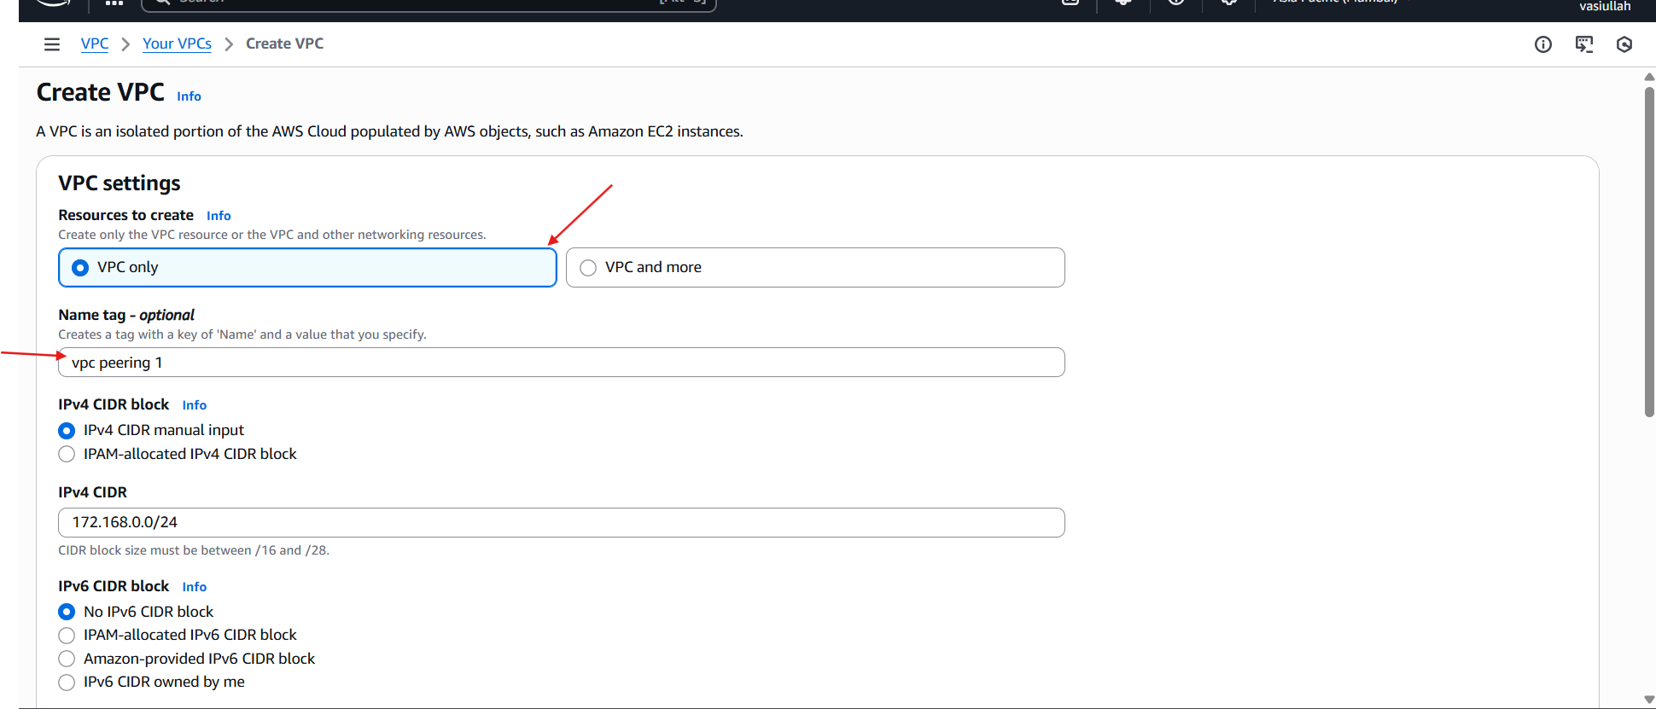

* **Go to the Ireland region**
* **Select vpc peering**🡪**select your**🡪 **peering connection**🡪**actions**🡪**accept request**

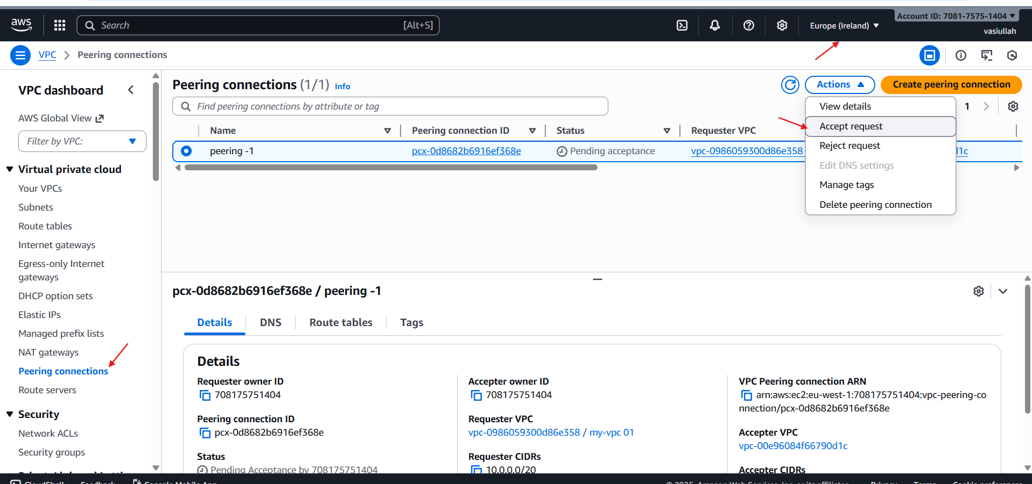

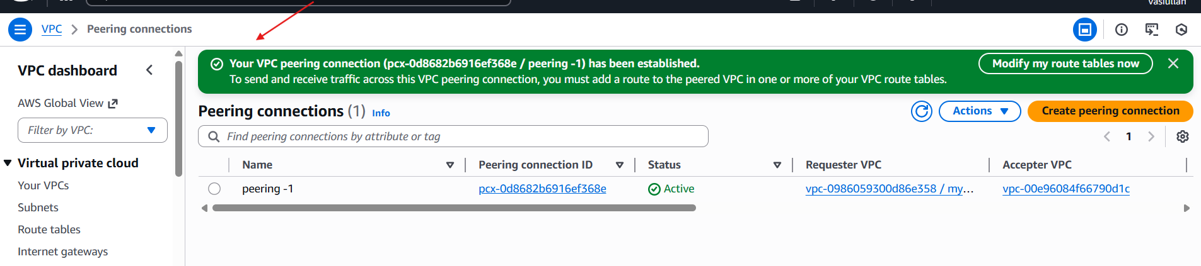

* **Go to the ohio region**
* **Select RT**🡪**Create RT**🡪**give the name**🡪**select vpc**🡪**and create RT**

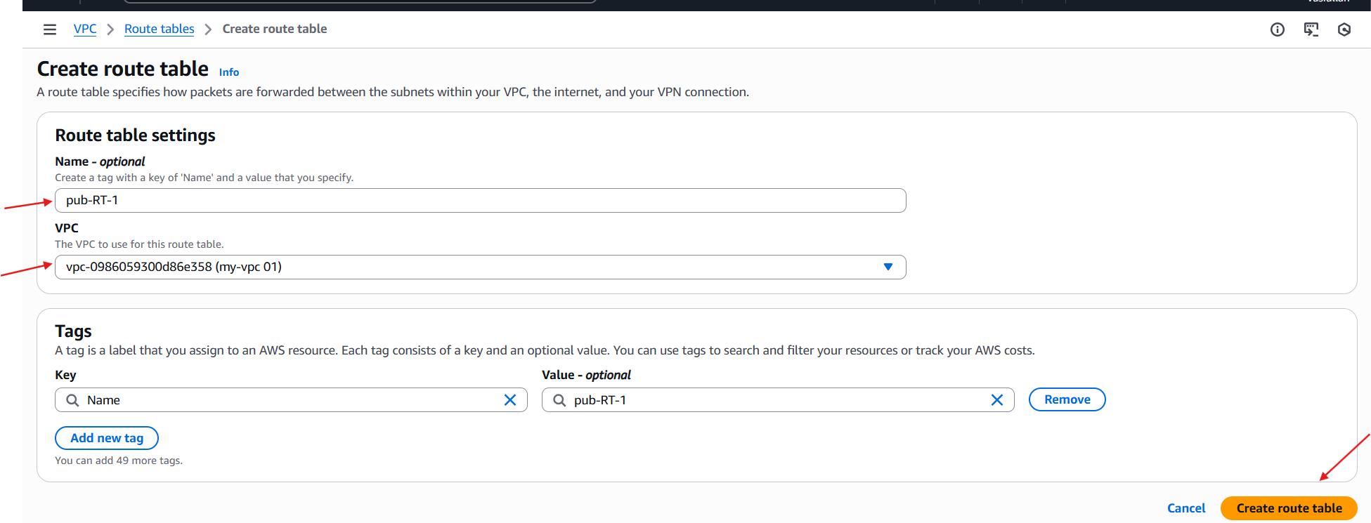

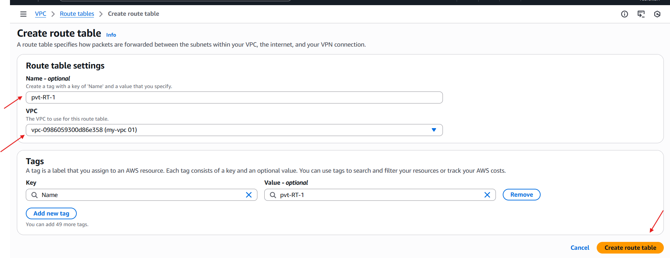

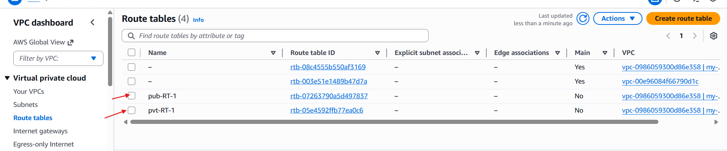

* **Create internet gateway and attach to the vpc**

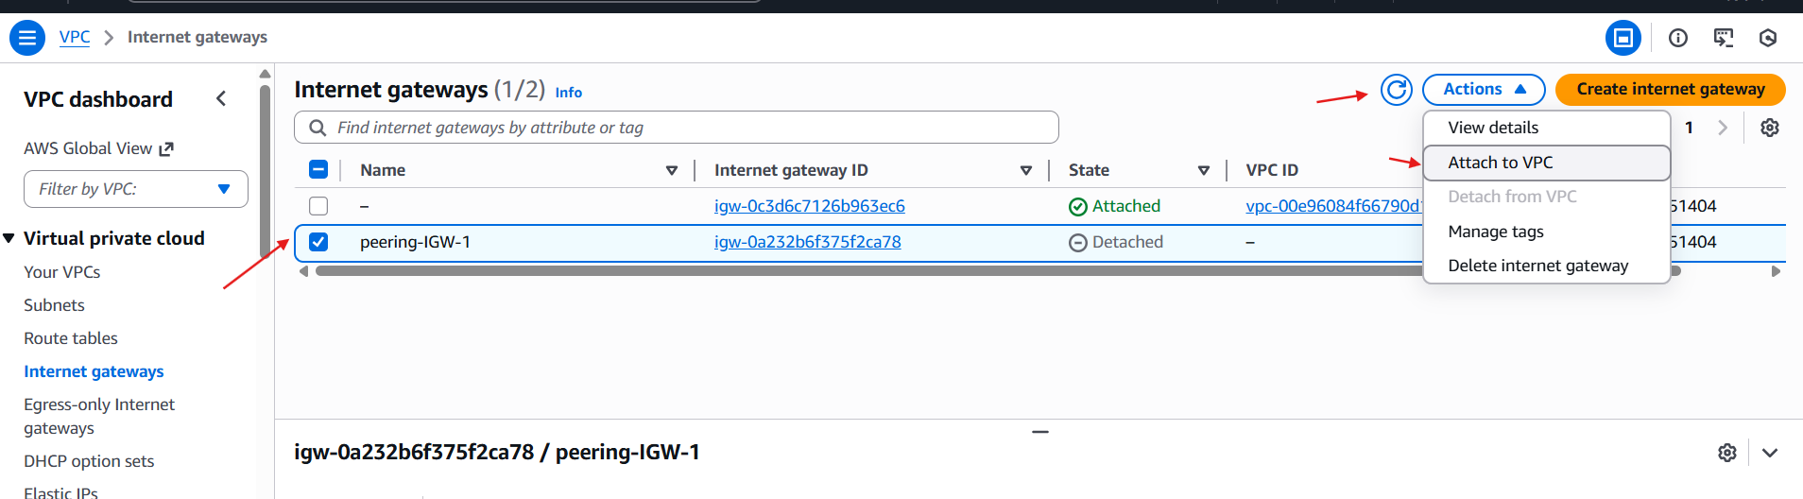

* **Go to the rout table and attach to the internet gate way**

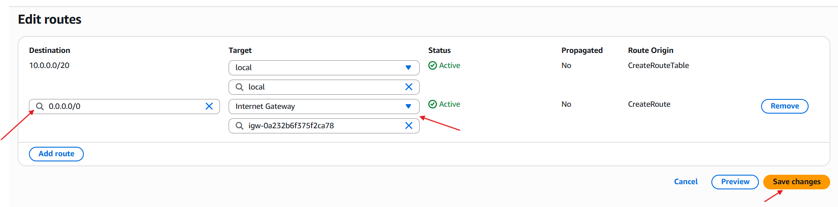

* **Internet gate way is attached**

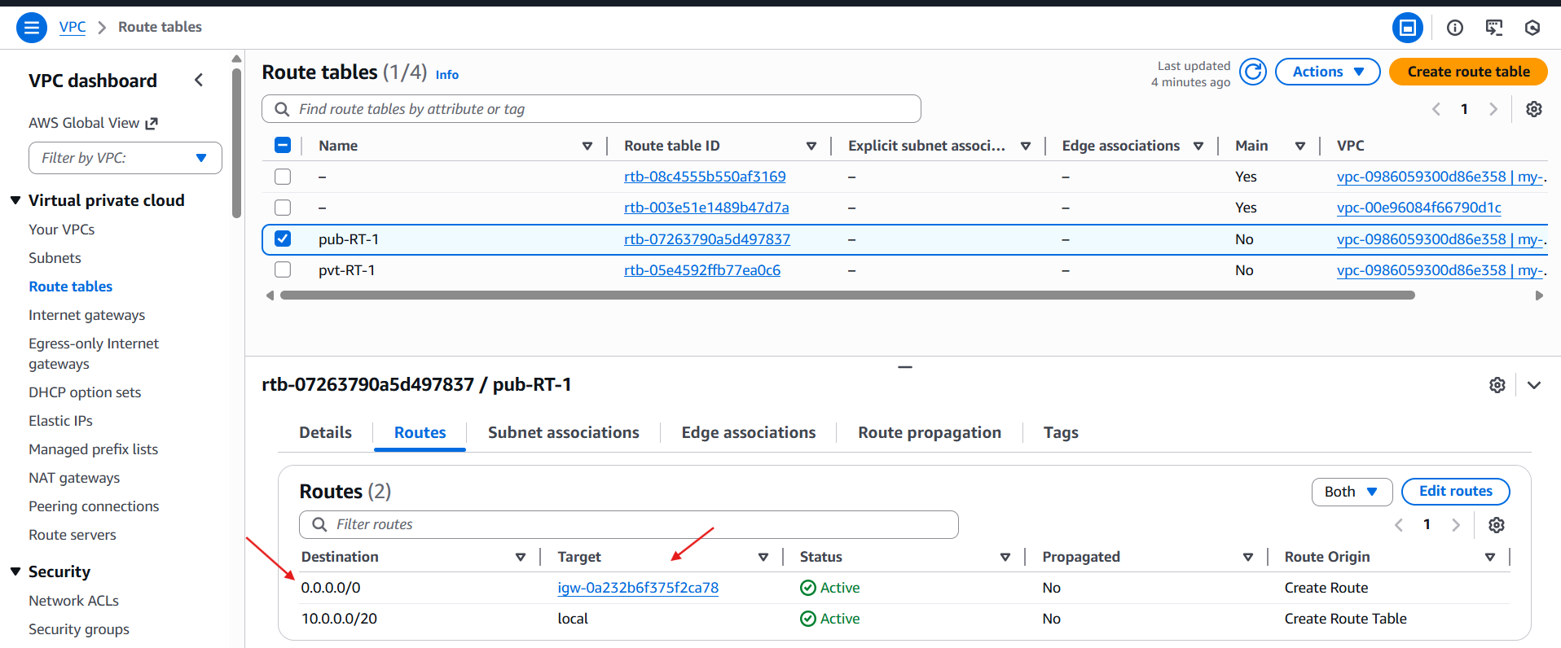

* **Change your region to lreland**

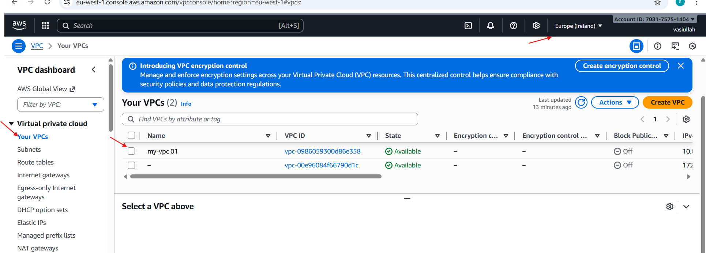

* **Go to the ohio region**🡪**RT**🡪

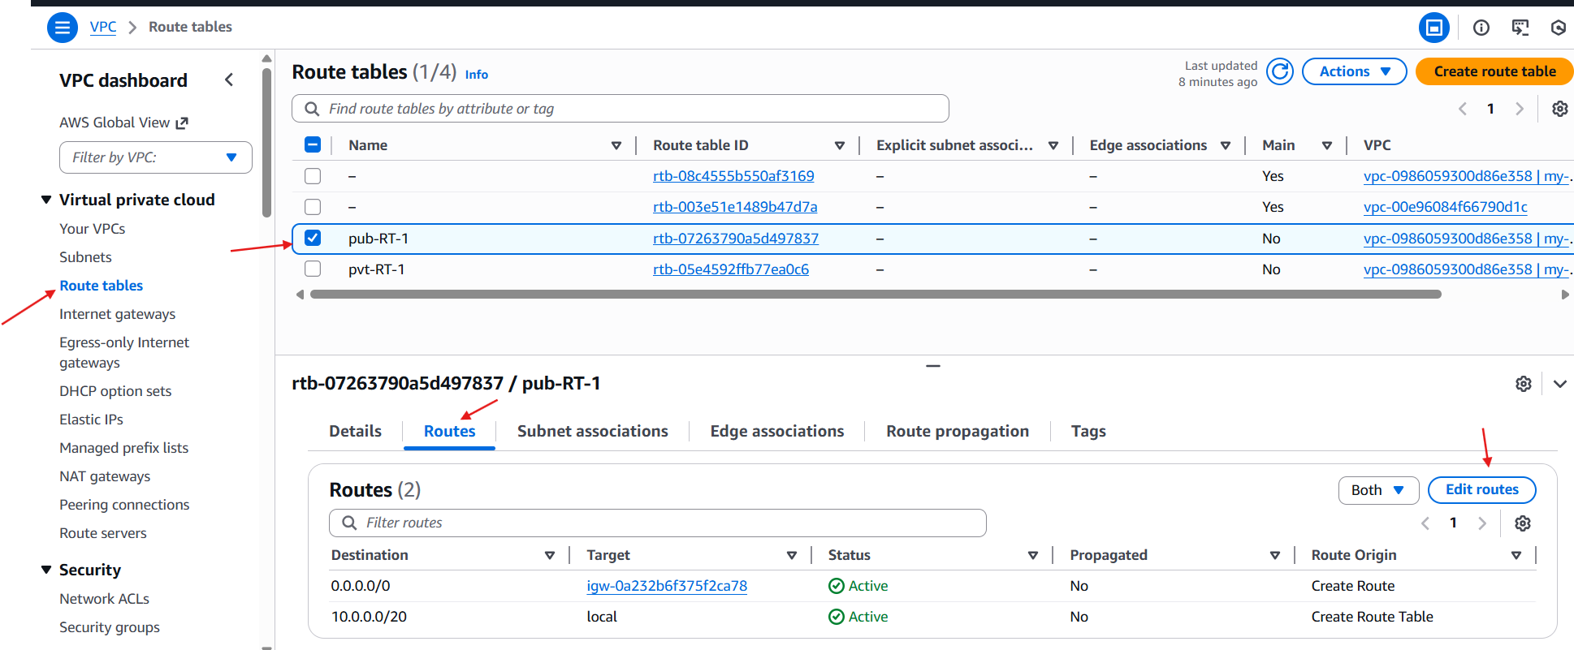

* **Go to the destination**🡪**select ip**🡪**select target**🡪**peering connection**

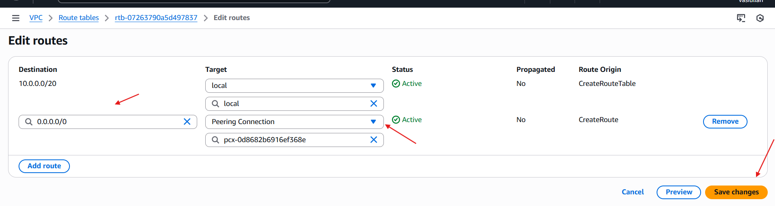

* **Successfully connected**

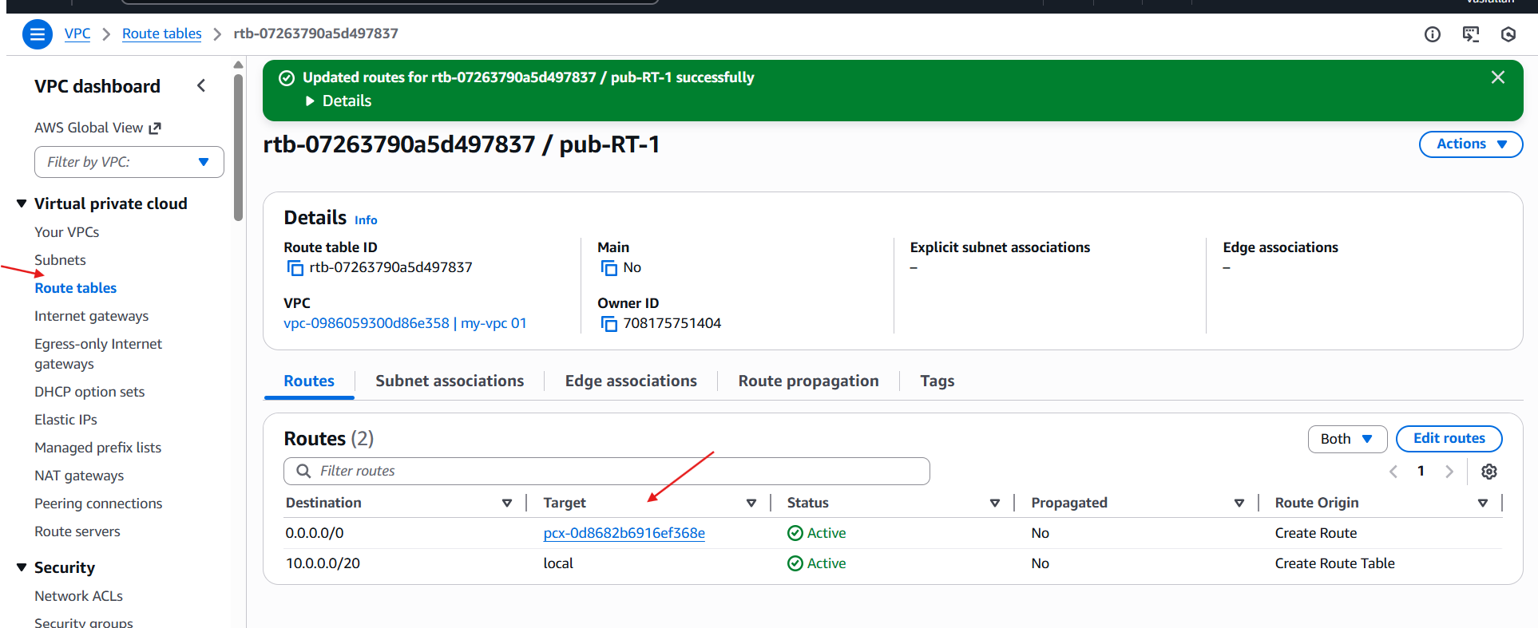

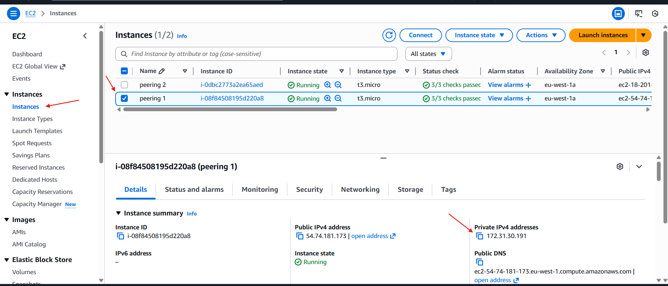

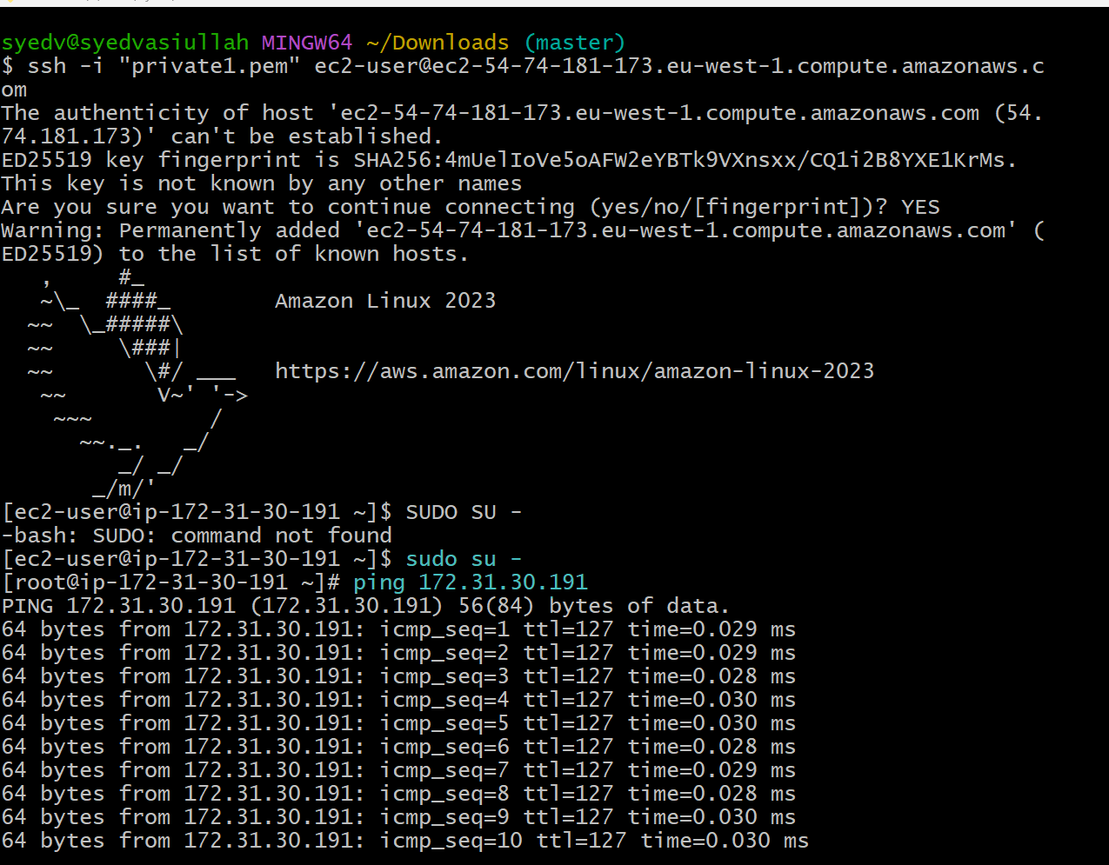

3. Enable VPC peering for cross-account (you can collaborate with your friend to do this task)

* Created one VPC

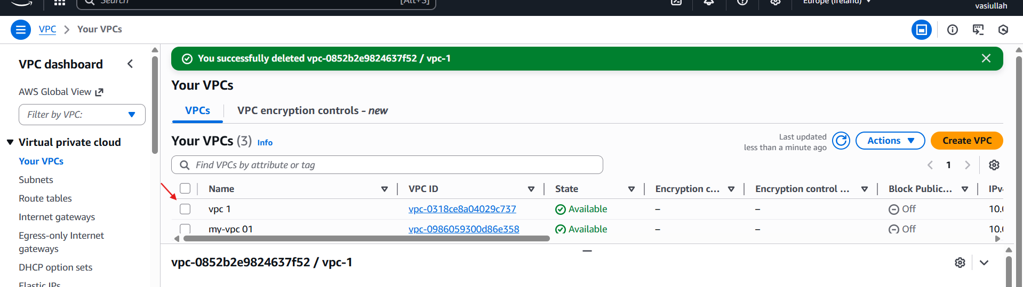

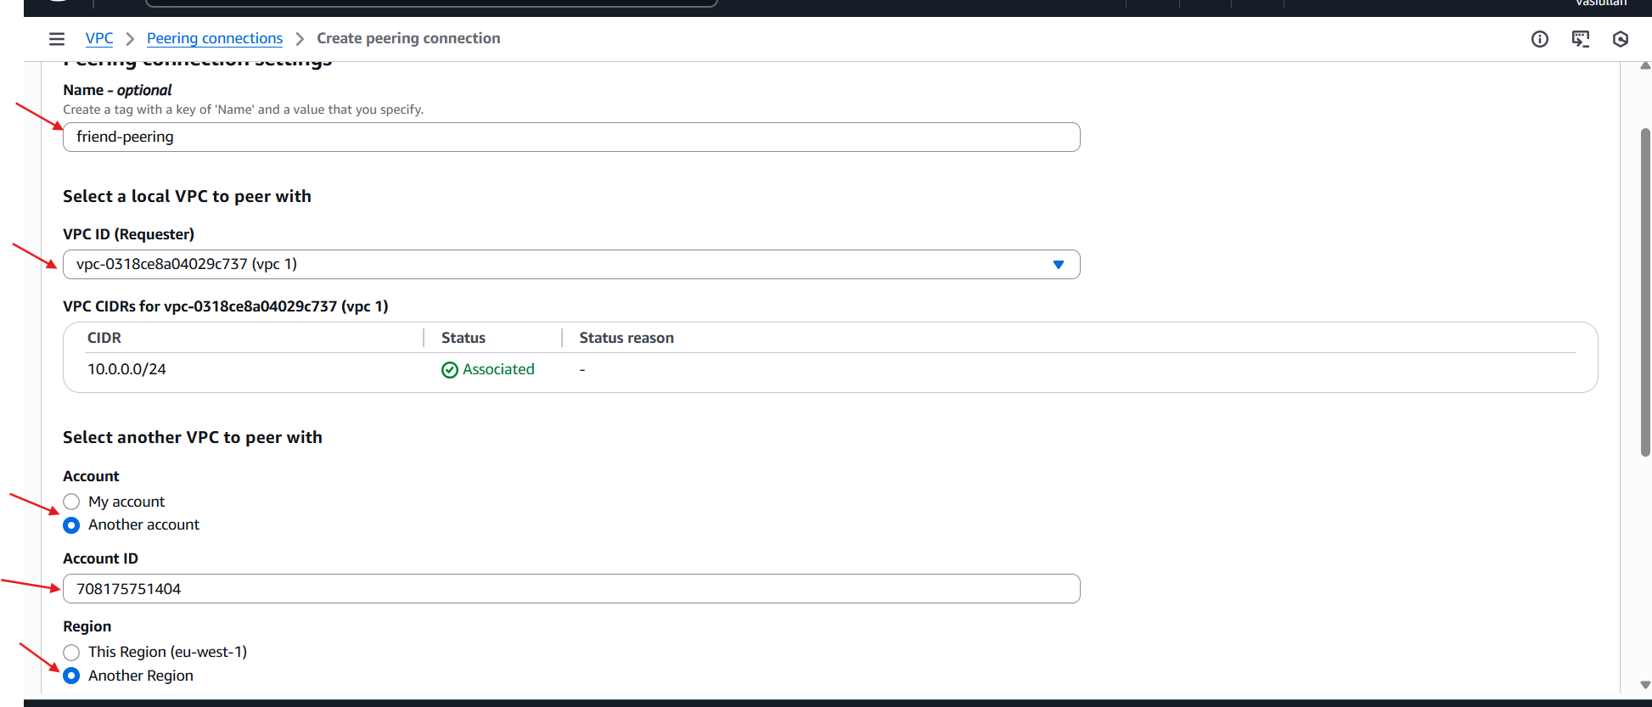

* Total details of peering with another account

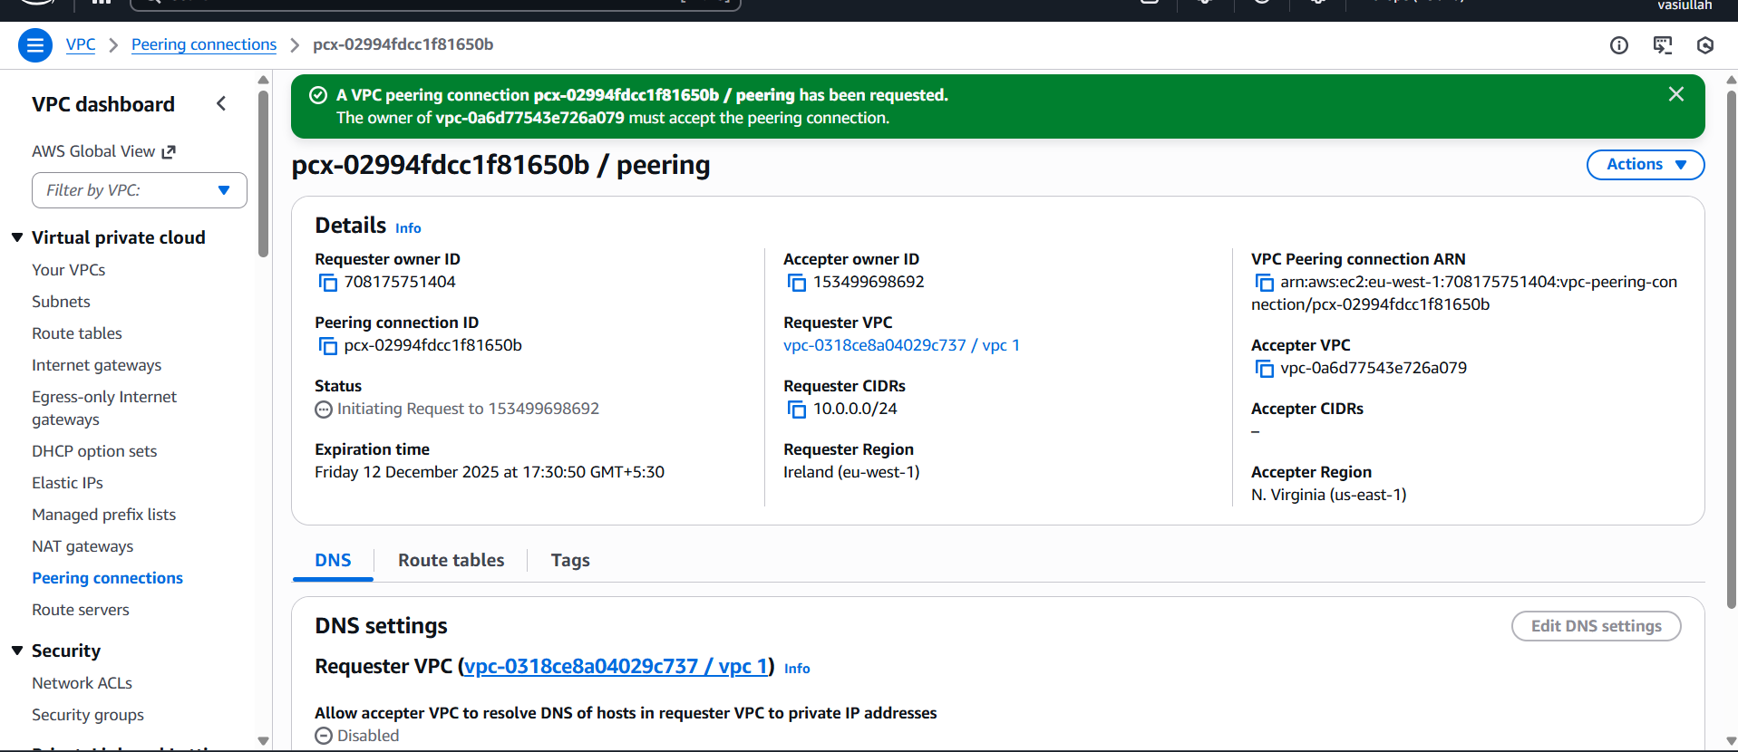

4. Set up a VPC Transit Gateway.

* **Create 2 VPC**
* **VPC-1**
* **VPC-2**

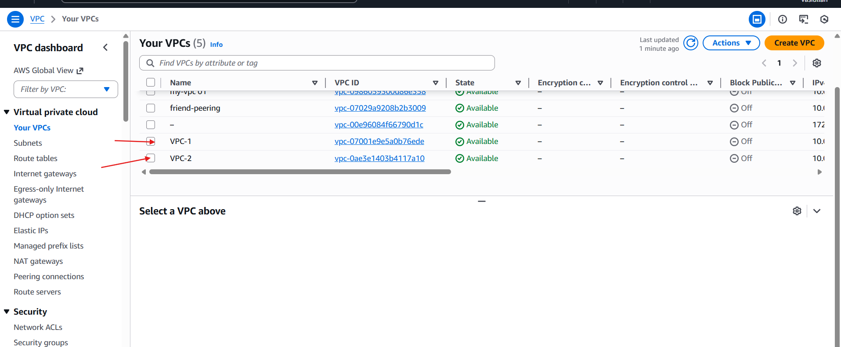

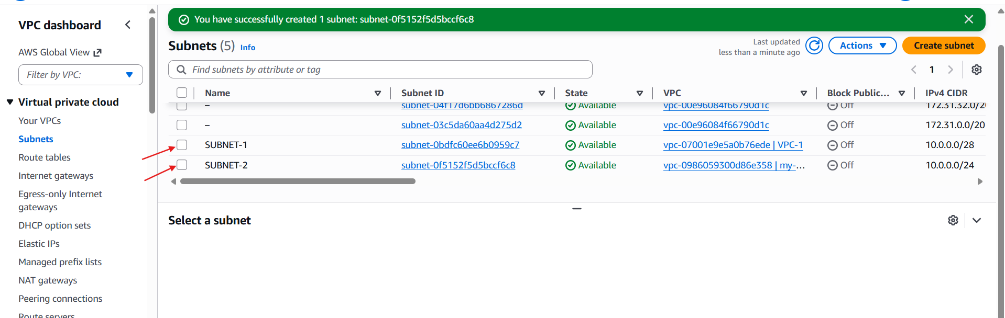

* Launch 3 ec2 instances🡪attach vpc
* For each instance attach he one on one vpc including with subnets

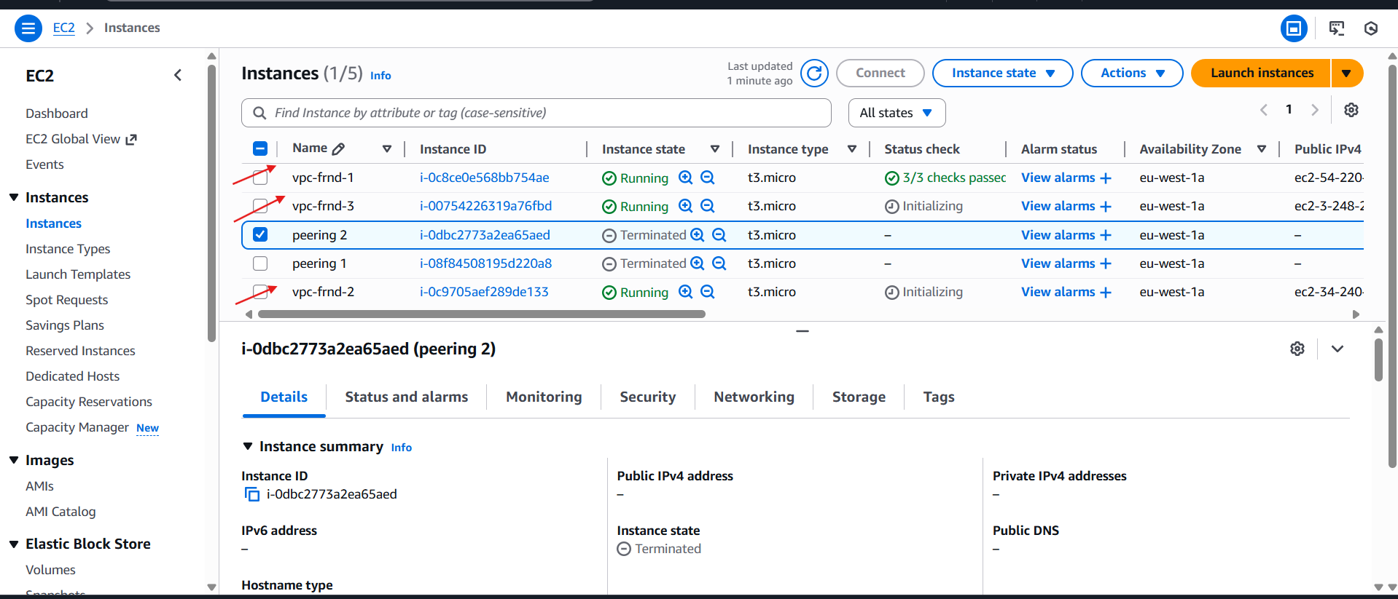

* Add in bound rules
* Ssh 🡪22
* All traffics 🡪 all

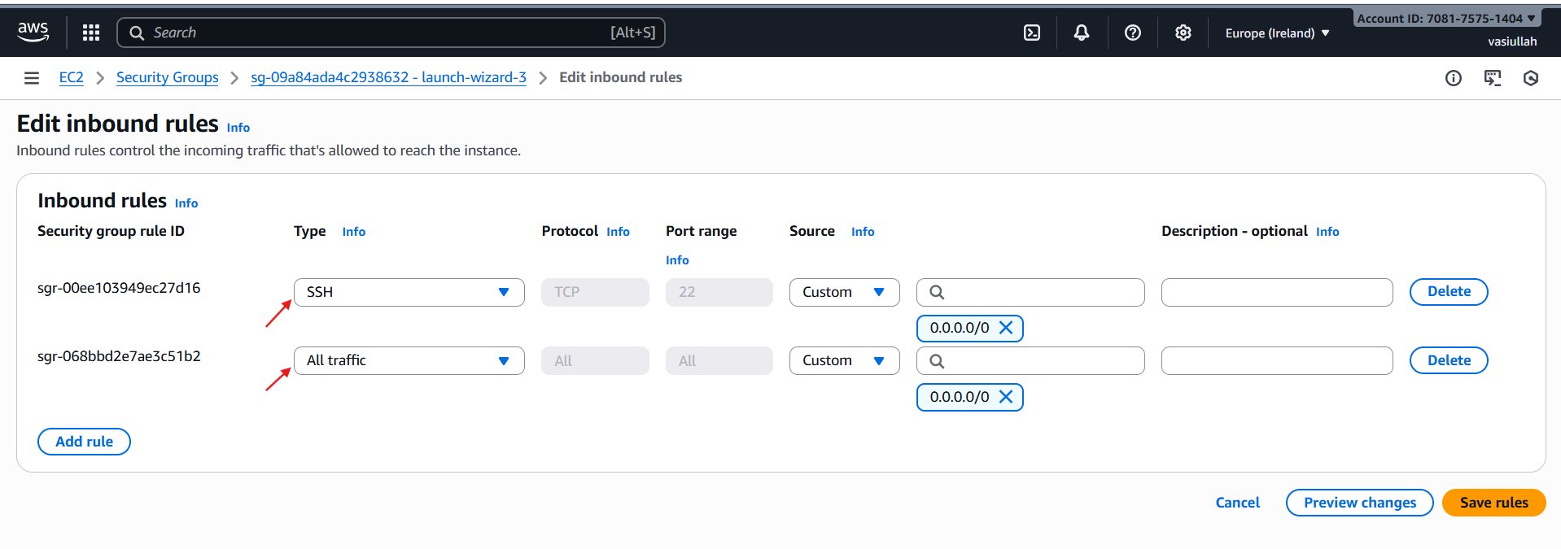

* Create transit gateway attachment and attach vpc’s

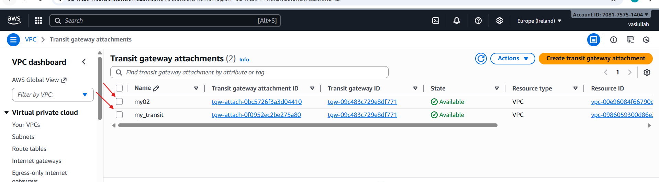

* Create 1 rout

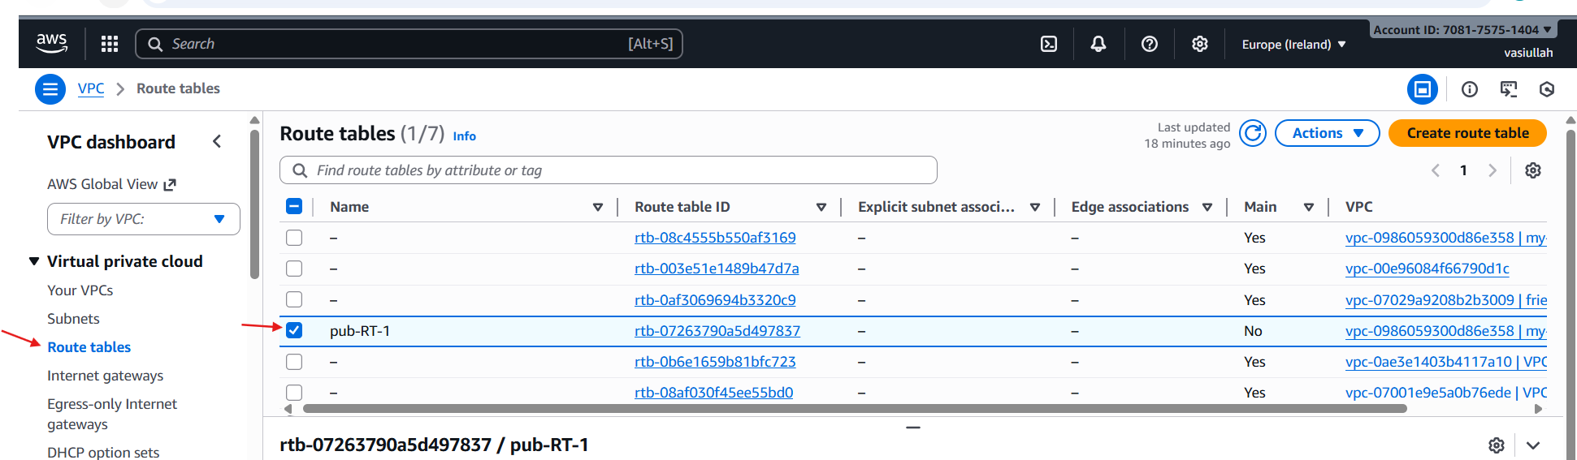

* Select RT 🡪 routs 🡪 edit rt

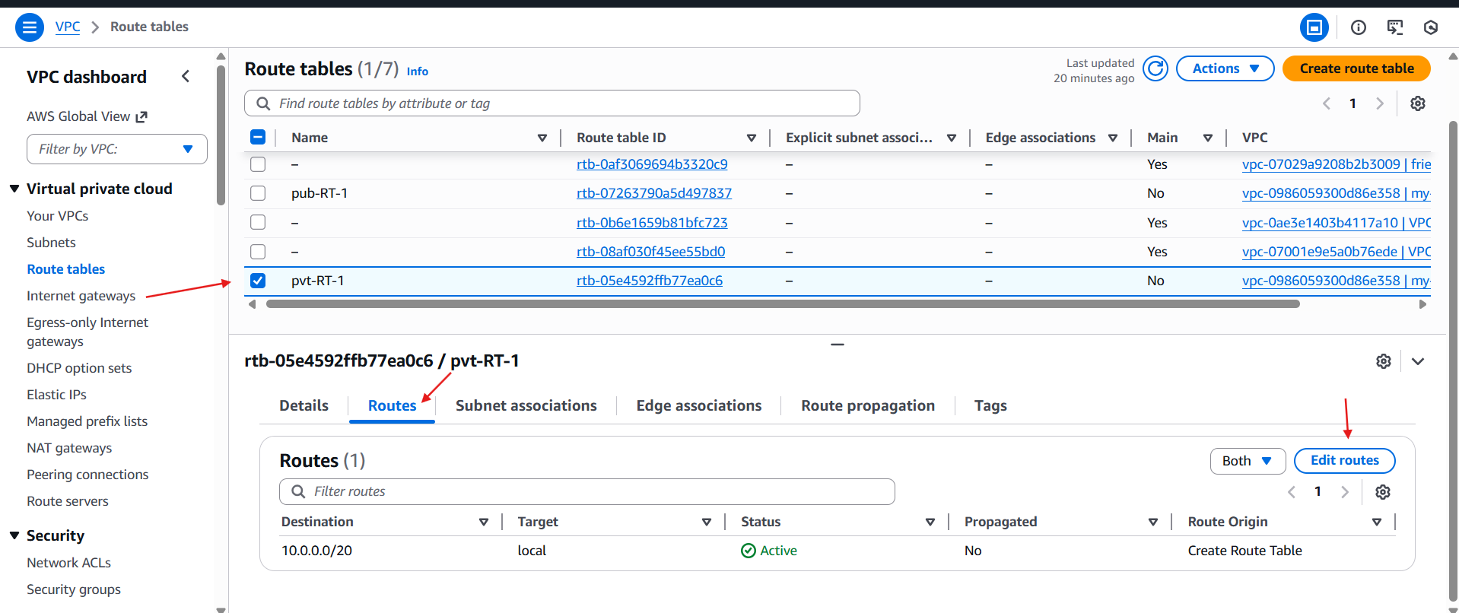

* One instance is connected

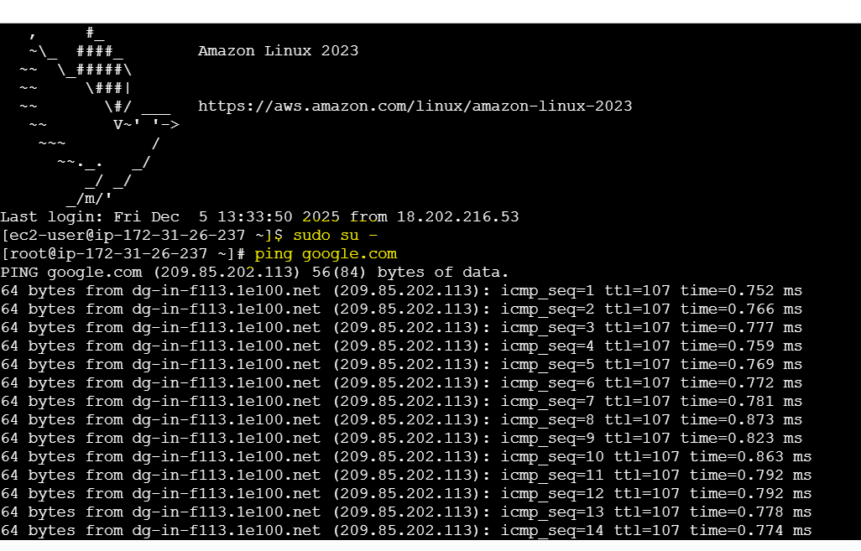

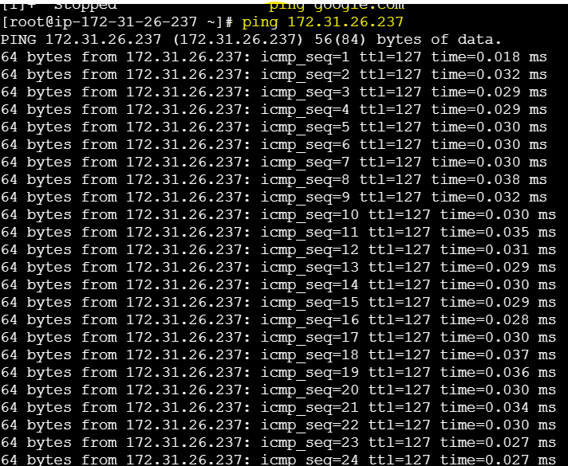

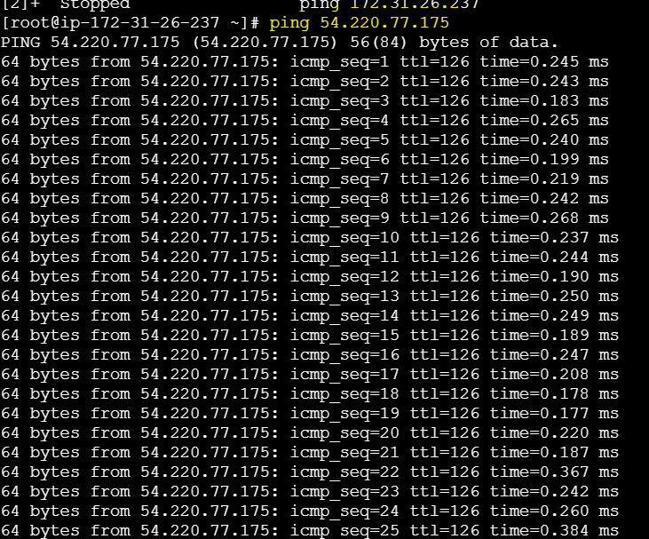

5. Set up a VPC Endpoint.

* Go to vpc-->create VPC
* create internet gateway-->attach to  created VPC

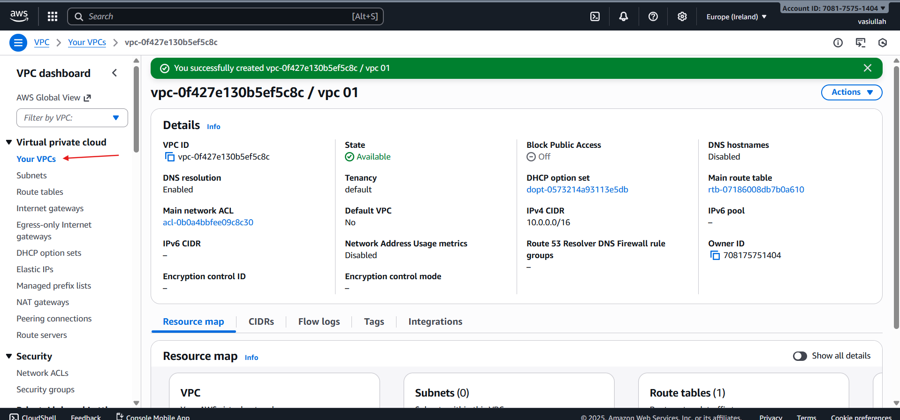

* create internet gateway-->attach to  created VPC

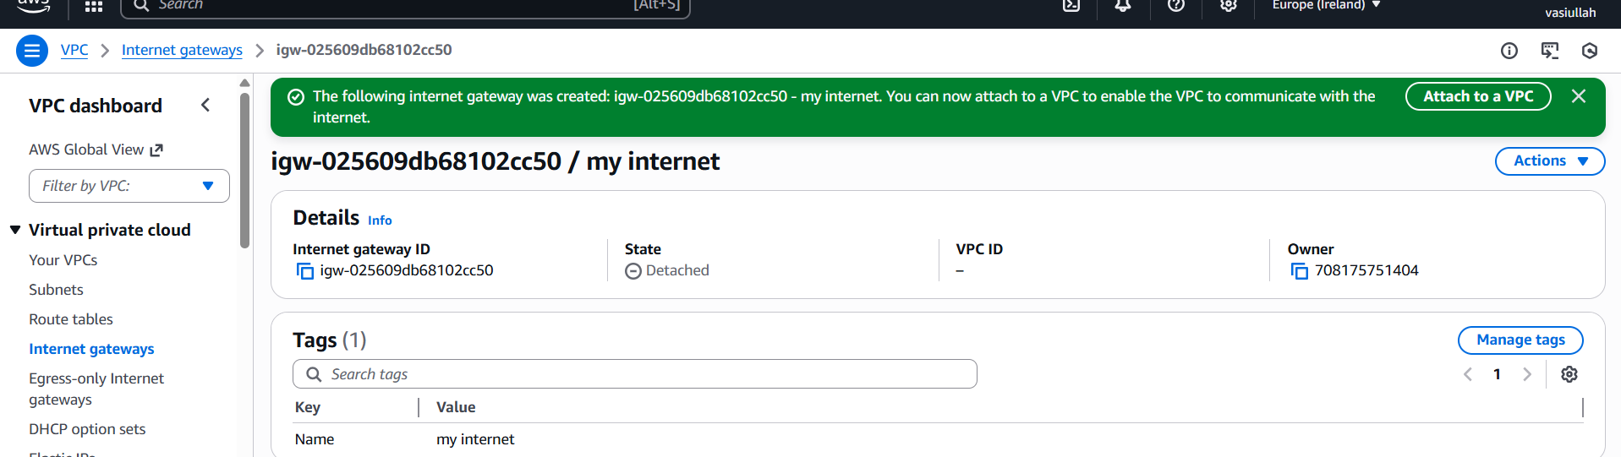

* create route tables public and private

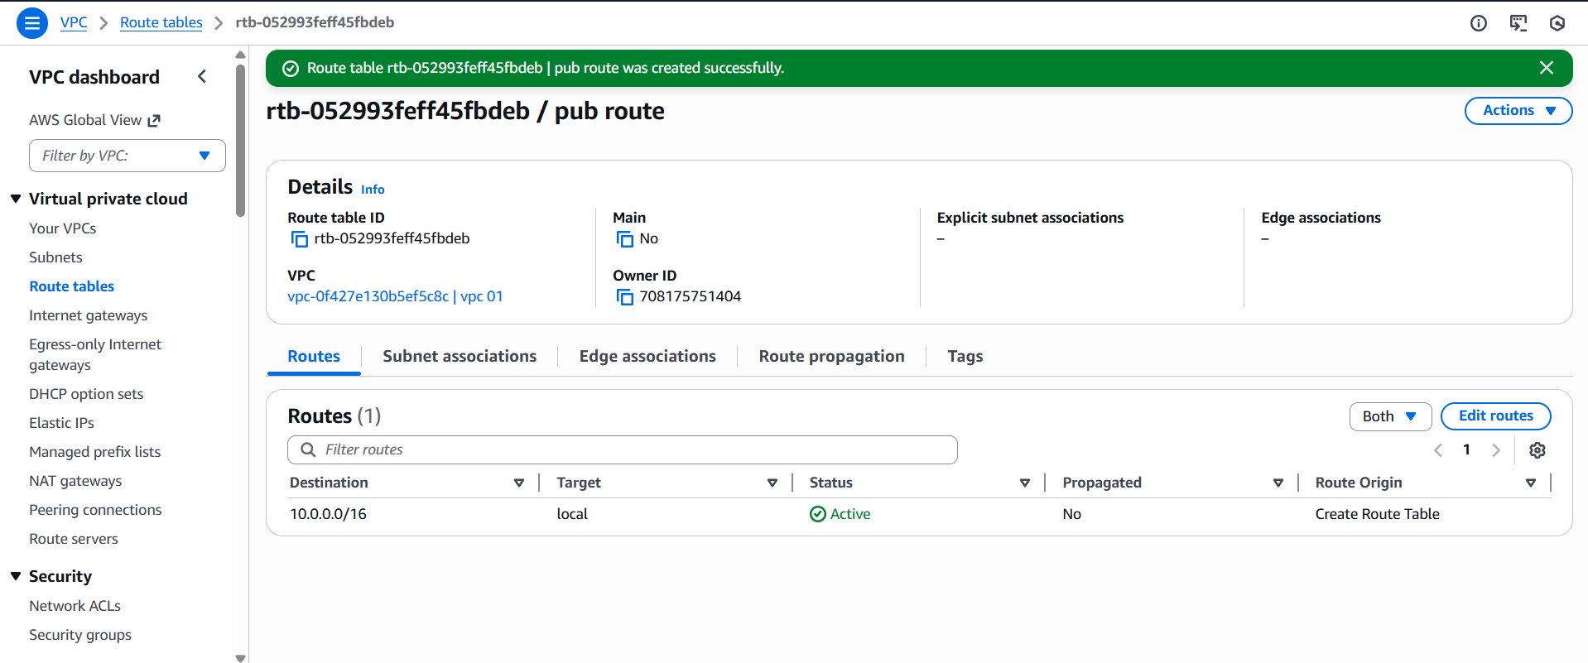

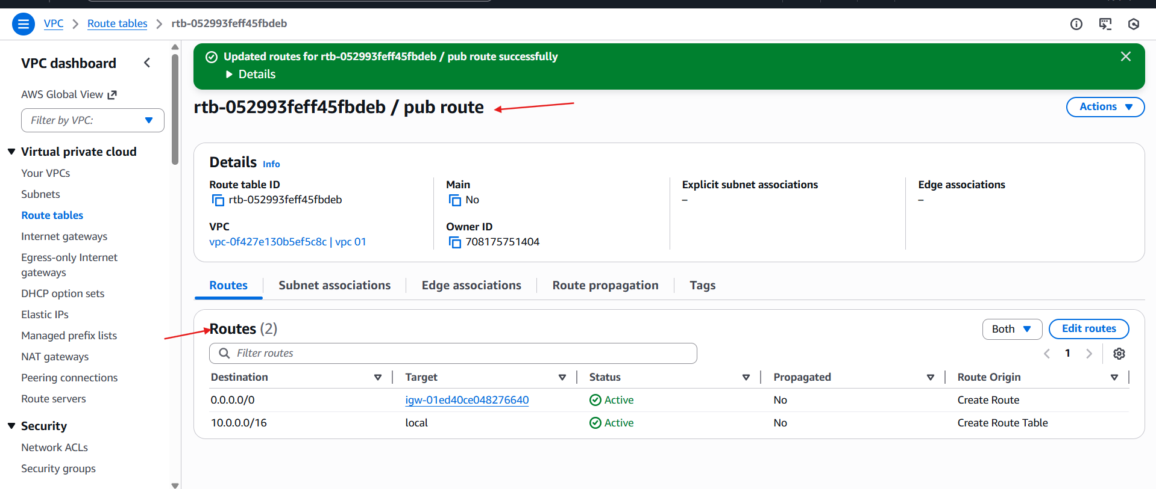

* **Create endpoint**

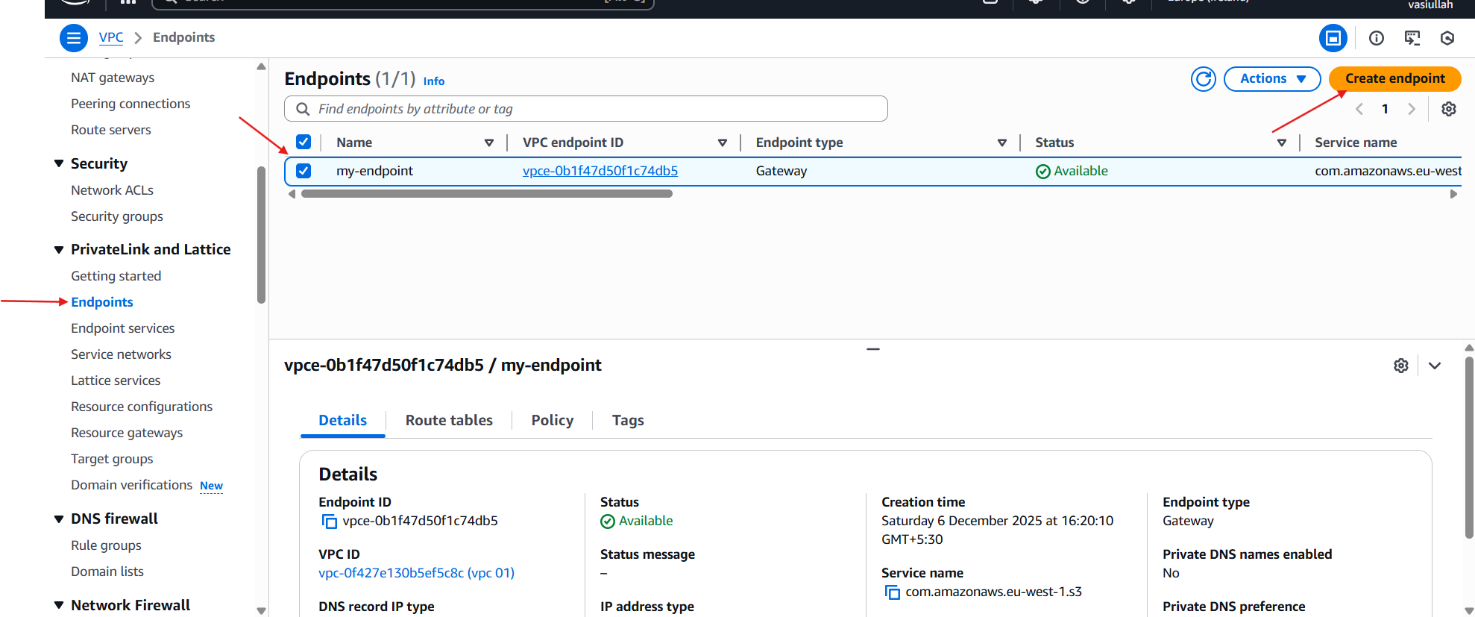

* Click **Create bucket**

